Angular 14

Session-01

1. TypeScript – Complete
2. Angular 14  
    [Angular 12,13,14]
3. End to End Application  
    MEAN Stack  
    M MongoDB Database

E Expresss MiddleWare  
 A Angular Front End  
 N Node JS Server Side

1. Deployment

2 Month course duration

What is Angular ?

Why Angular ?

What is difference between Angular and React ?

What are the challenges in modern web development ?

* Web introduced in early 1990’s by Tim Berners Lee
* We are developing applications for web from early 1990
* Angular and React were introduced in 2013
* Modern web is used by smart device users – 80%

1. Unified UX – every where should same features experienced like mobile or pc

2. Fluid UX – Continuously content loading while scrolling down like facebook, youtube etc.

3. Loosely coupled and extensible.

4. Simplified deployment

What is solution ?

* Better build SPA[Single page application]
* World first SPA – Twitter[before Angular and React]

How to build SPA ?

* HTML,CSS,JavaScript,jQuery : yes
* What are the issues in JavaScript and jQuery
* Lot of DOM manipulations
* Lot of references
* Heavy
* Explicit Ajax

What is solution ?

* React , Angular, Vue, Knockout, backbone, Ember etc..

What is difference between React and Angular ?

* React is a library of javascript – Building UI
* Angular is developers platform (from building to deploy)

[language, library, framework]

What is difference between Angular JS and Angular?

Session-02

* Early 2010 Google introduced angular JS for public domain
* Angular js have lots of issues

1. Angular JS have lots of GAPS(what cant full fil by this technology).
2. Angular JS is not built for what you are using
3. Angular JS JavaScript
4. JavaScript is not strictly typed language
5. it is not a strongly typed language
6. it will not support complete oop
7. extensibility issues
8. code security issues
9. Slow in rendering
10. Legacy library

Angular JS 1X version

* In 2013 Google angular JS Team
* Angular team started a new language called AtScript
* Microsoft already have a language called TypeScript

C# -Anders Hejberg - TypeScript

* Google angular team started integrating TypeScript with their new version angular 2
* angular 2 was designed as alternative for angular JS not replacement

What are the features of Angular ?

* Angular is not just a framework as angular JS
* it is a developers platform
* it provides end to end solution for developer
* it provides all library required from building ,debugging, testing to deploying.
* It is modular[only the library that is required will be included and loaded]
* application specific framework
* lightweight
* faster[angular is 10X faster than angular JS]
* supports TypeScript

1. strictly typed
2. strongly typed
3. oop supports

- Asynchronous approach

- latest version of angular is 14

What is deference between React and Angular ?

* React is javascript library
* Angular is framework with developers platform.

Session**-**03

TypeScript:

What are issues with JavaScript ?

* JavaScript is not default strictly typed.
* JavaScript is not strongly typed.
* It will not support all oop features.
* Security issues
* Extensibility issues

To overcome the above problem **typescript** comes into the picture.

* introduced in early 2003 by Microsoft Architect “Anders hejlberg”
* Angular,React,Vue and other javascript based technologies are now using typescript.
* Typescript is strictly typed.
* Typescript is strongly typed
* Typescript is an OOP language
* Typescript alone can build large scale applications
* Typescript is build with Typescript , means it does not need support like os to build.

**TypeScript Architecture**

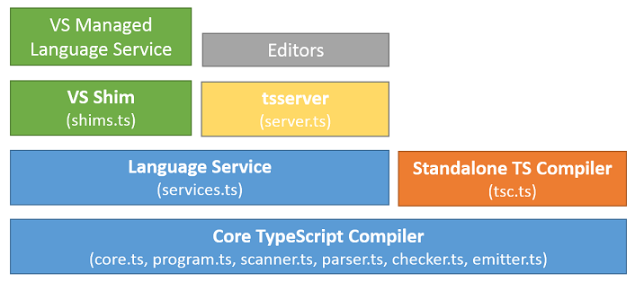

1. TypeScript core compiler

* Identify the error in program
* It translates the program into machine code.

1. core.ts : launch the program
2. program.ts : verify the program structure
3. scanner.ts : responsible for handling input
4. emitter.ts : responsible for handling output
5. parser.ts : converting one type to another
6. checkers.ts : checking data type
7. TypeScript standalone compiler

* It is used to transcompile the typescript program into javascript.

“tsc.ts”

1. Language Service (services.ts)

* Service is predefined business logic
* We can inject into application to implement specific functionality
* Service is a factory of functions and values used by typescript program.

Var categories =[]; Array

Categories.length

Categories.push()

* All the libraries present in language service.

1. TsServer(server.ts)

* Server is used for hosting
* Handling request and response
* Deploying – making ready to use
* TsServer is responsible for hosting and deploying typescript programs.

1. VsShim [shims.ts]

* Shim is responsible to translate your unmanaged code into managed code and managed code is platform neutral/
* Shims.ts will make typescript platform neutral.

1. Managed Language Service

* It is a set of factories with function with values that are supported cross platform

1. Editor

* Editor is tool for building,debugging,testing and deploying applications.
* Typescript supports all editors

editorconfig.org

Setup environment for typescript

1. Download and install “Node.js” on your PC

[Package Manager called NPM]

1. Yarn , bower,grunt,rubygems,nuget,NPM

Windows 8+

Node JS version 12 +

NPM version 6+

1. Check the version installed

node -v

npm -v

1. Download and install TypeSript on your PC

C:\> npm install -g typescript

C:\> tsc -v

Session-04

* Install following extensions for VS code

1. Live Server : Required for hosting and executing your web application
2. Angular Language Service : Required for angular support
3. Vs code icon : icon for various types of files
4. Intellisense for CSS class Names in HTML : CSS support

Create a web application with TypeScript

1. Create new folder in your pc
2. Open project folder name in VS code
3. Open terminal and run the command [use command promt]

* npm init -y [This will generate package.json]
* package.json comprises of project meta data.
* {
* "name": "typescript-webapp",
* "version": "1.0.0",
* "description": "",
* "main": "index.js",
* "scripts": {
* "test": "echo \"Error: no test specified\" && exit 1"
* },
* "keywords": [],
* "author": "",
* "license": "ISC"
* }

1. Add following folder into project

* public : it comprises of static resources like html,text,image,pdf,audio and video etc.
* src : It comprises of dynamic resources like css , sass, less , js ,ts etc.

1. Add a startup page for project in “public” folder by name index.html

! [tab key] for basic index page

1. In the status bar of VS code click on “Go Live”

Or

Right click on your index page and select “open with live server”

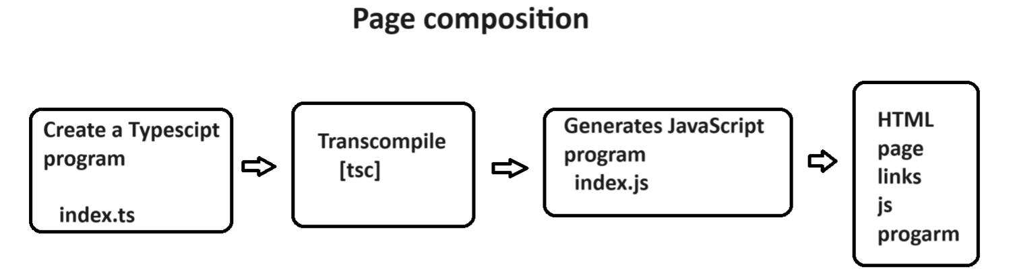

1. go to SRC folder and add a new typescript file

“index.ts”

function bodyload(){

    var username:string|null=prompt("Enter Name");

    document.querySelector("p").innerHTML = `Hello ! ${username}`

}

1. Open file location in “Integrated Terminal”

Src> tsc index.ts

1. This will generate “index.js”
2. Link the js file to your Index.html page

FAQ : How to decide which version of javascript to use for TypeScript

Ans: by using “tsconfig.json”

* tsc –init

Session-05

Creating a new project

Handling Typescript file

TsConfig > tsc --init

Package.json > npm init -y

TSLnt > Obsolate[No longer in use]

TypeScript Language

1. Language Basics

* Variables
* Data types
* Operators
* Statements
* Functions

Variables::

* Variables declaration, initialization and assignment are all same as java script.

1. var
2. let
3. const

Data Type

* data type determines the data structure.
* Javascript is implicitly types and not strongly typed

Let x=10; //number

x = “john” ; // string

let y : //undefined

* TypeScript is strongly typed.

Let variableName : data type;

* Typescript data type are same as java script.

1. Primitive Types

Number

String

Boolean

Null

Undefined

1. Non primitive types

Array

Object

Map

Syntax:

let username: string=”john”|’john’|`john`;

let age:number = 22;

let subscribed : Boolean = true;

* If you don’t defined data type for variable in typescript the it is default any type.

let username; // any type

let username : string // string

* Type script supports “Typescript Inference”

[If you initialize variable with a value then value type is used as data type]

Let username; //any

Username =”john”; //any

Username = 22; //any

Let username = “john”; // string // type inference

Username = 22; //invalid

* TypeScript supports union of types

let variable: datatype|datatype|datatype;

let username:string|number |boolean= "raj";//string

username = "john";

username = 30;

username = true;

Summary Primitive types

number : signed,unsinged,float,double,decimal,exponent

string : “”,’’,``

boolean : true/false [not 1 or 0]

null : null

undefined : undefined

let username : string|null = prompt(“Enter name”)

String Function:

* charAt()
* charCodeAt()
* indexOf()
* lastIndexOf()
* substring()
* substr()
* slice()
* match()

Array Type:::

* JavaScript array allows various types of values
* TypeScript can handle array in 2 ways

1. With similar type of values
2. With various value types

Syntax::

Let categories:string[]=[“Electronics”,”Footwear”];

Let sales : number[]=[1000.34000];

Let values : any[] = [“Electronics”,1300,true];

FAQ : what is difference between Array() and [] ?

Let values : string = new Array();

Let values : string[] = [];

Ans: Both are used for initialization of memory for array.

Array() can define size for array.

However in JS and TS array size can change dynamically.

Array() will allow to initialize only similar type of values even when the data type is defined as “any”.

The data type for values will be determined according to the first value type

Let values : any[] = new Array(20,”A”); // invalid

FAQ : What is Tuple ?

Ans : tuple is collection that allows to initialize any type of values.

Let values : any[] =[] ; //tuple

Let values : any[] = new Array() ; // array not tuple

* Array can handle various types of values

1. Primitive type
2. Not primitive type
3. Functions

* Javascript array from ES5+ supports destructuring.
* let values:any[]=["TV",45000,true,function(){console.log('Hello ! typescript')} ];
* let [productName,price,stock,hello]= values;
* console.log(`Name = ${productName}\n${price}\n${stock}`);
* hello();

>tsc index.ts

>node index.js

- Array Method all are same as java script

toString()

join()

slice()

find()

filter()

map()

pop()

shift()

push()

unshift()

splice()

indexOf()

lastIndexOf()

sort()

reverse()etc..

Object, Map – in next session

Session-06

Object Type::

* There is no specific data type for object
* “any” is used for objects

Let product : any = {

Key : value

}

* Key is always string
* Value is any type

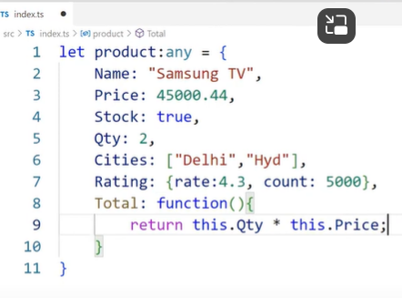 

Array of objects ::

* No specific data type for array of objects
* “any ” is used as data type
* 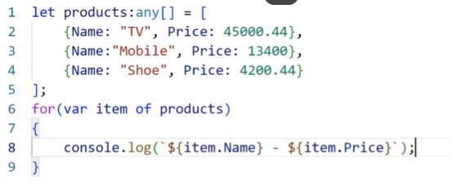

**Map Type ::**

* ES6 map type
* Collection of key and value.
* FAQ: What is the difference between map and object?

Ans :

Object Map

Key string Keys any

No size for keys can define size for keys

Requires iterators implicit iterators

for reading keys , value

slow in access fast in access

Syntax::

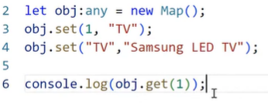

**Date type ::**

* No specific data type for date.
* “any” is used for data.
* “date ” is stored in memory by using “Date()”
* All date and time methods are same as in javascript.
* Syntax

let mfd : any = new Date(“2022-06-24”);

getHours()

getMinutes()

getSeconds()

getMilliseconds(0

getdate()

getDay()

getMonth()

getFullYear()

toLocaleDateString()

toLocalTimeString()

setHours()

setMinutes()

setSeconds()

setDate()

setMonth()

setYear()

**Regular Expression Type ::**

<input type =”text” pattern=”[A-Z]{4,10}”>

* JavaScript and typescript regular expression are defined in “/ /”

Syntax:

Let regExp:any = /[A-Z]{4,10}/;

* Regular expression is verified by using ‘match()’ method.

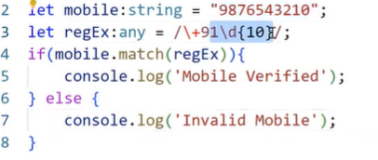

Summary : How to store various types of data in variable

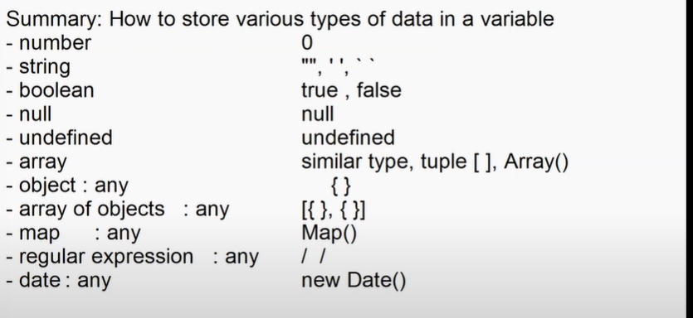

* Operators same as javascript

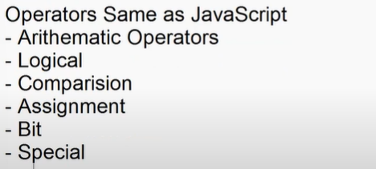

new , void,yield,in,of,typeof,delete,instanceof,etc.

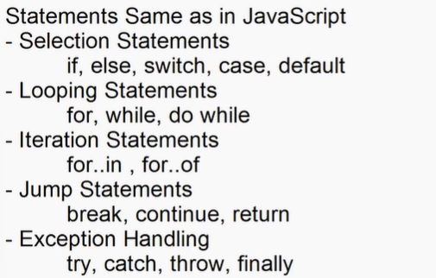

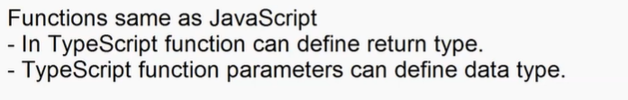

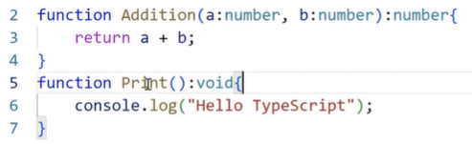

* Typescript function can defined optional parameters.
* Optional parameters is defined by using “null” reference characters ‘**?:**’.

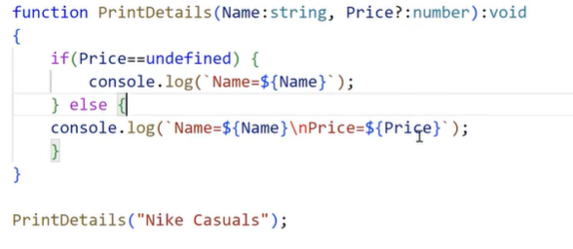

Note: Typescript function cant have required parameters following the optional parameters.



FAQ : What is Rest parameters?

Ans: Single parameter can handle multiple arguments

function(…params)

{

}

* Even function can have only one rest parameter
* Rest parameter must be the last parameter in formal list

Arrow function same as in javascript

Anonymous function

Callback function

Function recursion

Function closure etc..

**Session-07**

**TypeScript OOP :**

1. Contracts in OOP :

* Every component in OOP is designed as per contract.
* Contracts defines rules for designing a component.
* In OOP contracts are designed using “Interface”.
* Contracts can contain only rules no values.

**Syntax:**

**interface IName{**

**//rules…**

**}**

EX:

interface IProduct{

    name:string;

    price:number;

    stock:boolean;

}

let product:IProduct ={

    name:"Samsung Tv",

    price:44000.44,

    stock:true

}

console.log(`Name=${product.name}/nPrice=${product.price}/nStock=${product.stock}`);

for(var p in product){

    console.log(`${p}`)

}

* Contract can contain optional rules

interface IProduct{

    name:string;

    price:number;

    stock:boolean;

    rating?:number; // optional rules

}

* Optional rules in contract can be defined using “null reference character - ?”

Syntax:

Interface IName{

Property ?:Datatype;

}

* Contracts can be defined read-only rules.
* Every rule defined in contract can be re-assigned with a new value.
* If you want any rule to define property that cant be changed after initialization then configure it as “readonly”.

Syntax:

Interface IName{

Readonly property:datatype;

}

EX:

interface IProduct{

    readonly name:string;

    price:number;

    stock:boolean;

    rating?:number;

}

let product:IProduct ={

    name:"Samsung Tv",

    price:44000.44,

    stock:true,

    rating:4.4

}

product.name="Nike running shoes"; //Invalid

product.price = 6000.34;

product.stock=false;

product.rating=4.5;

* Contract can define rules for methods.
* Rule of method comprises of

1. Return type
2. Parameter type

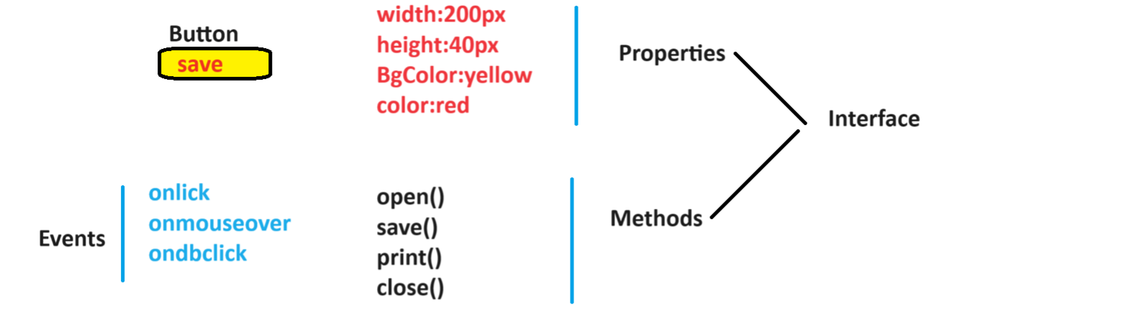

* Rule is for signature of method not for definition

Syntax:

Interface IName{

Method():Datatype;

}

* Methods also can be optional.

Syntax:

Interface IName{

Method()?:Datatype;

}

EX:

interface IProduct{

    readonly name:string;

    price:number;

    stock:boolean;

    rating?:number;

    qty:number;

    total():number;

    print?():void;

}

let product:IProduct ={

    name:"Samsung Tv",

    price:44000.44,

    stock:true,

    rating:4.4,

    qty:2,

    total:function(){

        return this.qty * this.price;

    },

    print:function(){

        console.log(`

          Name : ${this.name}\n

          Price : ${this.price}\n

          Stock : ${this.stock}\n

          Rating : ${this.rating}\n

          Qty : ${this.qty}\n

          Total : ${this.total()}

        `)

    }

}

product.print();

* A contract can extends another contract.
* When you design an app with multiple versions it will have contracts extended.

EX:

interface IBank_Version1{

    personal:string;

    nri:string;

}

interface IBank_version2 extends IBank_Version1{

    agri:string;

}

let LatestHDFC : IBank_version2 = {

    personal:"Personal Banking",

    nri: "NRI Banking",

    agri:"Govt. Schemes"

}

let LegacyHDFC:IBank_Version1 = {

    personal:"Personal Banking",

    nri:"NRI Banking"

}

**Session-08**

Typescript OOP :

* Contracts -> Interface
* Rules for properties
* Rules for method
* Optional rules
* Readonly rule
* Extending rules

1. Simple

one contracts extending another

1. Multi level

Extended contract is again extended

1. Multiple

Contracts will support multiple inheritance

EX:

interface IProduct{

    name:string;

    price:number;

    stock:boolean;

}

interface ICategory{

    categoryId:number;

    categoryName:string;

}

interface ProductDetails extends IProduct,ICategory{

    print():void;

}

let TV:ProductDetails ={

    name:"TV",

    price:56000.00,

    stock:true,

    categoryId:1,

    categoryName:"Electronics",

    print:function(){

        console.log(`Name:${this.name}\nPrice:${this.price}`)

    }

}

**Class in OOP :**

* Class is a program template.
* A template comprises of pre-defined logic and data , which you can implement and customize according to requirements.
* Class is referred as entity when it is mapping to client requirements.
* Class is referred as modal when it is mapping to data requirements.
* A class in typescript can contain only 4 members

1. Properties
2. Methods
3. Accessors
4. Constructors

FAQ: Can we declare a variable directly in class ?

Ans : No.

FAQ: Why variable is not allowed in class ?

Ans: variables are Immutable types.

EX:

class Demo{

    var x =10;//Invalid

}

FAQ: Can we declare function directly in class?

Ans: No> Funtion are Immutable.

* Data is stored in properties
* Logic is defined in methods.

FAQ: What is difference between Method and function?

Ans: Function is Immutable | Function intended to return a value

Method is mutable | Methods may or may not return a value.

* Typescript class can have static and non-static members.

Static:

- static refers to continuous memory.

- Memory allocated for first object will continue for second object.

- developer uses static members for continuous operations.

- It will be fromm applications start to application end.

No-static

- It refers to discreet memory.

- Memory will rest for every obect

- developer uses non-static members for discreet operations.

- it will be from session start to session end.

EX:

class Demo{

    static s:number =0;

    n:number=0;

    constructor(){

        Demo.s = Demo.s+1;

        this.n=this.n+1;

    }

    print():void{

        console.log(`S=${Demo.s} N=${this.n}`);

    }

}

let obj1 = new Demo();

obj1.print();

let obj2 = new Demo();

obj2.print();

let obj3 = new Demo();

obj3.print();

* Typescript classes will support access modifiers.

1. Public

* Public is accessible within the class or outside the class.
* You can access by usong class object or derived class object
* You can access in derived class or outside class.

1. Private

* It is accessible only within the class

1. Protected

* It is accessible within the class
* It is accessible outside the class but,only with in derived class and only by using derived class object.

EX:

class Base{

    public name:string='';

    private price:number=0;

    protected stock:boolean=false;

    print(){

        console.log(`Name=${this.name}\nPrice=${this.price}\nStock=${this.stock}`)

    }

}

class Derived extends Base{

    print(){

        let obj = new Derived();

        obj.stock;

        obj.name;

    }

}

**Session-13 (from 9 to 12 same as previous)**

**Class Members :**

1. Property:

* It is used to store data
* It is defined with access modifier and data type.

Syntax:

Public propertyName:datatype=value;

FAQ: What is the difference between a variable and property?

Ans : Variables are Immutable[structure cant change]

Properties are Mutable [structure can change]

1. Accessors:

It provides a fine grained control over property.

You can control the property and its structure using accessors.

Accessors are of two types

1. Getter – used to read the value
2. Setter – used to set the value

Syntax:

get propertyName()

{

Return value;

}

set propertyName(new Value){

Value = newValue

}

**Ex: A**ccessing property without accessor

class Product{

    public name:string="TV";

}

let tv= new Product();

tv.name="Samsung TV"; //set

console.log(`TV=${tv.name}`) //get

FAQ: How to restrict a property from storing new values?

Ans: by marking it as ‘readonly’.

EX:

public readonly name:string="TV";

FAQ: How to configure a property that can change its behaviour according to state and situation?

Ans: By using Accessors.

EX

var userName:string|null = prompt("Enter user Name");

var role:string|null= prompt("Enter your role");

var productName:any= prompt("Enter product name");

class Product{

    public _productName:any; // _ requires further implementation, just a tradition

    get ProductName(){

        return this._productName;

    }

    set ProductName(newName:string){

        if(role=="admin"){

            this._productName=newName;

        }else{

            document.write(`Hello ! ${userName} - You are not authorised to product name`)

        }

    }

}

let obj = new Product();

obj.ProductName = productName;

if(obj.ProductName){

    document.write("Product Name = "+obj.ProductName);

}

Note : link js file to html to run the dom manipulation.

* You can also use accessors to access any node from multilevel hierarchy.

Ex:

class Product{

    public name:string="";

    public price:number=0;

    public rating:any={

      RegisterUserRating:{

        rate:4.2,

        count:56000

      },

      GuestUserRating:{

         rate:3.2,

         count:4600      }

    }

    get GuestRating(){

        return this.rating.GuestUserRating.rate as Number;

    }

}

let obj = new Product();

console.log(obj.GuestRating);

Summary:

* Property
* Accessor

**Methods :**

* Methods and function are used for “Refactoring”.
* Refactoring is a technique of extracting a function or method for set of statements , so that you can reuse.

FAQ: what is differenece between method , function,procedure?

Ans:

**Session-14**

Class in Typescript

* Properties
* Accessors

**Methods :**

* Typescript methods are same as javascript methods
* Typescript method can configure data type parameters and return type

EX:

class Demo{

    public name:string="";

    public price:number=0;

    public qty:number=0;

    public Total():number{

        return this.qty *this.price;

    }

    public print():void{

        console.log(`Name=${this.name}\nPrice={this.price}\nQty=${this.qty}\nTotal=${this.Total()}}`);

    }

}

let obj = new Demo();

obj.print();

* Method can pe parameterized and parameterless.
* Typescript support optional parameters [“?”]
* Optional parameter must be last parameter.
* Require parameters can occur after optional parameter.
* Method supports rest parameter “…param”.

**Constructor :**

* It is used for instantiation
* Javascript and typescript constructor both are same.
* Constructor must be anonymous [no name].

EX:

(function(){

        document.write('hello !');

    })(); //anonymous function

FAQ: What is purpose of anonymous function ?

Ans : Anonymous specifies a function without name. They are used in callback and promise. Callback and promise means function will execute according to situation.

* Constructor is a software design pattern used to create an instance for class.
* Every class implicitly have a constructor.
* Explicitly we can add a constructor in class to configure the actionws to perform at the time of instantiation.
* Constructor is a special type of sub routine(methods) that executes automatically.

EX:

class Database{

    constructor(){

        console.log("Connected..");

    }

    public insert():void{

        console.log("Record Inserted..");

    }

    public delete():void{

        console.log("Record Inserted..");

    }

}

let oracle = new Database();

oracle.insert();

* Constructor can be parameterized or parameter less.

FAQ: if constructor is parameterized then when the parameter are passed?

Ans: At the time of allocating memory for object.

* var obj = new ClassName(p1,p2,..);

EX:

class Database{

    constructor(dbName:string){

        console.log("Connected.."+dbName);

    }

    public insert():void{

        console.log("Record Inserted..");

    }

    public delete():void{

        console.log("Record Inserted..");

    }

}

let oracle = new Database("oracle");

oracle.insert();

* All constructor parameter rules are same as for methods and function.
* Typescript constructor cant be private.
* Typescript cant overload constructor[only one constructor allow in class].
* If derived class is having a constructor then it must have **super call**;
* Super class constructor must be called in derived class constructor.

EX:

class Base{

    constructor(){

        console.log("Base class constructor..");

    }

}

class Derived extends Base{

    constructor(){

        super();

        console.log("Derived class contrustor..");

    }

}

Summary:

* Properties
* Accessors
* Methods
* Constructor

**Templates** :

* Template provides pre-defined logic and data , which you can implement and customize according to your requirements.

EX:

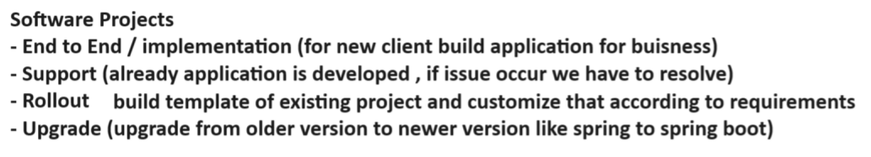

* Templates are designed by using “Abstract ” class.

**Session-15**

* Template are used in rollout and end to end.
* Templates are designed by using “Abstract ” class.

Interface 🡺 contracts

Abstracts -> Templates

* Abstract class comprises of members classified into two types

1. Implemented.
2. To be Implemented.

* Any member to be implemented is marked as abstract.
* If a class contain at least one abstract member then the class also must be marked as abstract.
* You cant create an object for abstract class. As it is incomplete class.
* abstract class is extended by another class.

Syntax:

abstract class className{

public method(){};

public abstract method();

}

class DerivedClass extends className{

method(){};

}

* The process of hiding structure of a component and providing only functionality is know as “Abstraction”.

EX:

interface ProductContarct{

    name:string;

    price:number;

    qty:number;

    Total():number;

    Print():void;

}

abstract class ProductTemplate implements ProductContarct{

    public name:string="";

    public price:number=0;

    public qty:number=0;

    public abstract Total():number;

    public abstract Print():void;

}

class ProductComponent extends ProductTemplate{

    name = "Samsung TV";

    price = 45000.44;

    qty = 3;

    Total(){

        return this.qty * this.price;

    }

    Print(){

        console.log(`Name=${this.name}\nPrice=${this.price}\nQty=${this.qty}\nTotal=${this.Total()}`);

    }

}

let obj = new ProductComponent();

obj.Print();

Output:

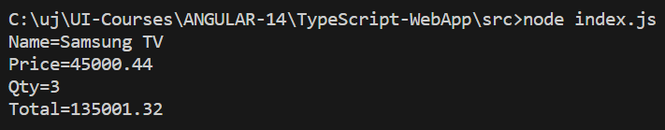

Note: Rules are implemented and Templates are extended.

FAQ: What is Abstraction?

Ans : It is the process of hiding the structure of component and providing only functionality.

Summary

1. Contracts [Interface]
2. Templates [Abstract class]
3. Components [class]

**Polymorphism :**

* **WHATWG – Build html**
* **Javascript – MDN Brendan Eich**
* **Typescript – Microsoft MSDN**

EX:

class Employee{

    public firstName:string="";

    public lastName:string="";

    public designation:string="";

    public print():void{

       document.write(`${this.firstName} ${this.lastName}  ${this.designation}`)

    }

}

class Developer extends Employee{

    public firstName: string="Sanjay";

    public lastName: string="kumar";

    public designation: string="Developer";

    role = "Developer Role : Build,Debug ,Test";

    print(){

        super.print();

        document.write(this.role);

    }

}

class Admin extends Employee{

    public firstName: string="Raj";

    public lastName: string="kumar";

    public designation: string="Admin";

    role = "Admin Role :Authorization";

    print(){

        super.print();

        document.write(this.role);

    }

}

class Manager extends Employee{

    public firstName: string="Pinsu";

    public lastName: string="Singh";

    public designation: string="Manager";

    role = "Developer Role :Approvals";

    print(){

        super.print();

        document.write(this.role);

    }

}

let employees = new Array(new Developer(),new Admin(),new Manager());

FAQ: What is difference between implements and extends ?

Ans : Contracts are implemented and classed are extended.

FAQ: Can we extend contract ?

Ans: yes.

FAQ : Can we create object for template ?

Ans: NO.

FAQ: Why multiple inheritance is not supported for classes but supported for interface ?

Ans: Classws leads to constructor Deadlock.

Interface will not have constructor.

**Modules :**

* Module is collection of variables , functions , contracts , templates and components.
* Modules are used to build a library for applications.
* Library allows to re use the resources.
* Modules require a module system.
* Modules systems are various types

1. Common JS
2. Require JS
3. UMD (Universal module distribution)
4. AMD (Asynchronous Module Distribution)

* Typescript by default uses a module system called “Common JS”.
* Any member define in a module is accessible only to the current module.
* If you want any member of a module to be accessed from another module then you have to mark it as “export”.

Syntax:

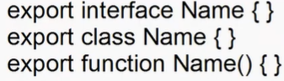

* Every module can have one default export.Default means loaded in memory automatically. It is not mandatory.

Syntax:

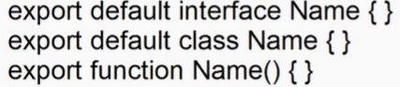

* The members of any module can be imported into the current module.

Syntax:

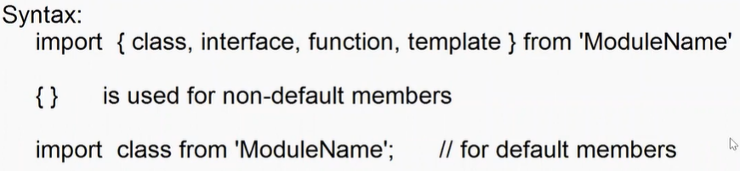

* Module system use DI mechanism. [Dependency Injection].
* DI is a design pattern that specifies how an object get holds of its dependencies.
* DI uses 2 major component

1. Provider
2. Injector

* Provider locates the dependencies the loads into memory.
* Injector is responsible for injecting the dependencies.

EX:

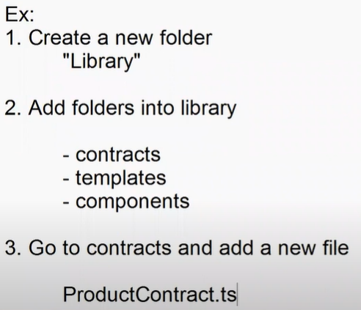

EX:

//module

export default interface ProductContract{

    name:string;

    price:number;

    qty:number;

    total():number;

    print():void;

}

export interface CategoryContract{

    categoryName:string;

}

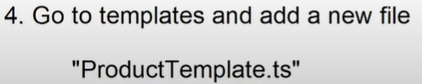

Ex:

import ProductContract ,{CategoryContract} from "../contracts/ProductContracts"

export abstract class ProductTemplate implements ProductContract,CategoryContract{

    public name:string="";

    public price:number=0;

    public qty:number=0;

    public categoryName: string="";

    public abstract total():number;

    public abstract print():void;

}

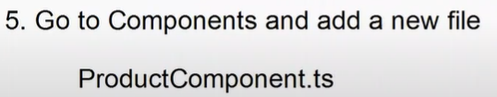

EX:

import { ProductTemplate } from "../templates/ProductTemplates";

export class ProductComponent extends ProductTemplate{

    name = "Samsung TV";

    price = 34300.33;

    qty = 2;

    categoryName = "Electronics";

    total(){

         return this.qty * this.price;

    }

    print(){

        console.log(`Name=${this,this.name}\nPrice=${this.price}\nqty=${this.qty}\nCatName=${this.categoryName}\nTotal=${this.total()}`)

    }

}

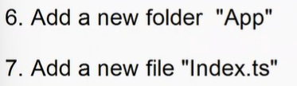

EX:

import {ProductComponent} from '../Library/components/ProductComponent'

let tv = new ProductComponent();

tv.print();

**Session-18**

**Namespace :**

* Namespace is a collection of sub-namespace and modules.
* You can build and import library using namespace.
* Members are configured in a file within the namespace.

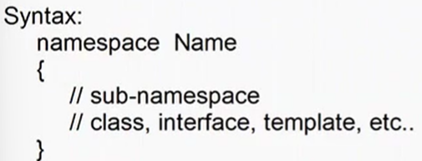

* If you want to access namespace outside the declared scope then mark it as “export”.
* if you want to import library from namespace then you have to use “///” directive.

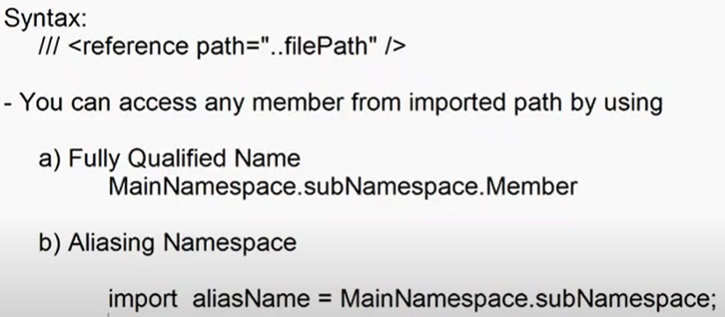

Note : Understand the concept later..

**Genrics** :

* Generic is used to configure type safe members.
* Initially it is open to handle any type of value, once it knows the data type then it becomes strongly typed.
* You can configure generic for

1. Property
2. Class
3. Method

EX:

var Demo = /** @class */ (function () {

    function Demo() {

    }

    Demo.prototype.Add = function (a, b) {

        console.log("".concat(a, "-[").concat(typeof a, "] - ").concat(b, " - [").concat(typeof b, "]"));

    };

    return Demo;

}());

var obj = new Demo();

obj.Add("john", "David");

obj.Add(30, 40);

**Session-19**

**Generic Class And Properties** :

* Generic type can handle operators directly.
* You have to use function to handle any specific operation.

EX:

function sum(a,b){

    return a+b;

}

class Demo{

    public Add<T>(a:T,b:T){

        return sum(a,b);

    }

}

let obj = new Demo();

console.log(obj.Add<number>(10,30));

console.log(obj.Add<string>("Raj","Kumar"));

Class as Generic Type:

EX:

interface IOracle{

    username:string;

    password:string;

    database:string;

}

class Database<T>{

    public connectionString:T;

    public connect(){

        return this.connectionString;

    }

}

let oracle = new Database<IOracle>();

oracle.connectionString = {

    username:"scott",

    password:"tiger",

    database:"empdb"

}

for(var property in oracle.connect()){

    console.log(`${property} : ${oracle.connect()[property]}`)

}

FAQ: What is the purpose of making a Generic class ?

Ans : Creating Generic Entity. All members are type safe.

* Generic can be any type

1. Primitive
2. Non-Primitive
3. Custom Type

EX:

interface IProduct{

    name:string;

    price:number;

    stock:boolean;

}

interface ICustomer{

    firstname:string;

    email:string;

}

class DataService{

    public getAllDetails<T>(data:T){

        return data;

    }

}

let product = new DataService();

let products:IProduct[] = product.getAllDetails<IProduct[]>([{name:"TV",price:34500,stock:true}]);

let customer = new DataService();

let customers:ICustomer[]=customer.getAllDetails<ICustomer[]>([{firstname:"Pinsu",email:"pins@gmail.com"}]);

console.log(`-------Product List------`);

for(var item of products){

    console.log(item.name);

}

console.log(`-------Customer List------`);

for(var c of customers){

    console.log(c.firstname);

}

**Enums-Enumeration :**

* It is a collection of constants.
* It can be string,number,or expression.
* It can have expression that returns only string or number.
* Enums are defined using “enum”.

Syntax:

Enum Name{

Key = value;

}

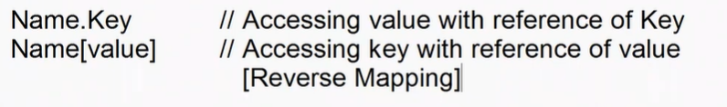

Ex:

enum WeekDays{

    sunday = 0,

    mon = 1,

    tue =2,

    wed = 3,

    thr = 4,

    fri = 5,

    sat = 6

}

let manufactured : any = new Date("2022-02-18 08:20");

console.log(`Manufactured Week Day : ${WeekDays[manufactured.getDay()]}`)

* Enum numeric constant can implement the value according to previous value.

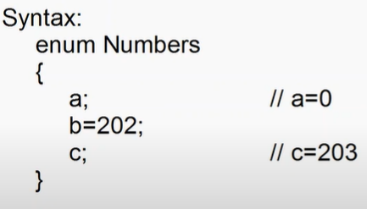

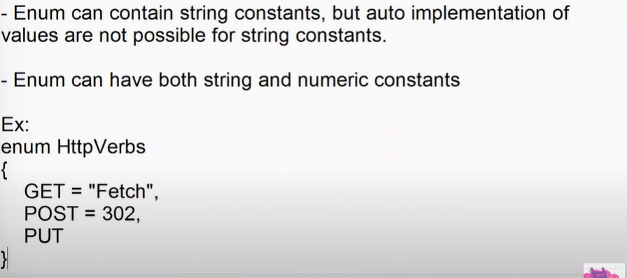



* Enum can also have expression, but its must return string or number.



>,<,+,-,*,/

EX:

enum Total{

    qty = 2,

    price = 4500,

    result = qty * price

}

console.log(`Total = ${Total.result}`)

**Session-20 :**

**Angular**

* Angular is a developer platform.
* Developers platform provides end to end solutions for developers i.e from building to deploying.

1. Building
2. Debug
3. Test
4. Deploying

* Angular is technically a framework developed by google and maintained by a large community of developers and organizations.
* A framework allows to build the application and control the application flow.
* Angular uses various frameworks implicitly like

1. MVC
2. MVVM

* Angular framework comprises of various concepts.

1. Factories – set of functions and values
2. Services – set of factories
3. Components – building blocks for applications
4. Modules – set of classes, contracts,templates.
5. Namespaces – set of modules
6. Pipes – used for transformation
7. Techniques
8. Routing
9. State management
10. Model binding
11. Data binding
12. Event binding
13. Class binding
14. Style binding
15. Templates

* Angular 2 Version in early 2013
* Latest Angular version is Angular 14
* Upto Angular 12 LTS [Long term support]
* Update Angular 11 no longer supported.[LTS End]

Setup Environment for Angular

1. Install Node.js
2. Install typescript
3. Install VS code
4. Install Angular CLI

C:\> npm install -g @angular/cli

* Angular CLI is command line tool provided by angular to create and manage your angular project.

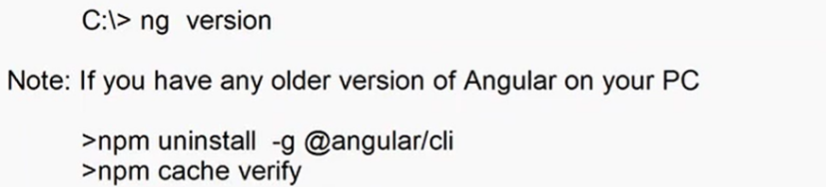

* npm install -g @angular/cli
* ng version

Create angular workspace :-

* angular workspace will host a set of projects [angular apps]
* it provides a common library for multiple projects.

1. Open your pc location in command prompt, where you want to create workspace.
2. Run the following command

C:\> ng new angular-worksapce --create -application=false.

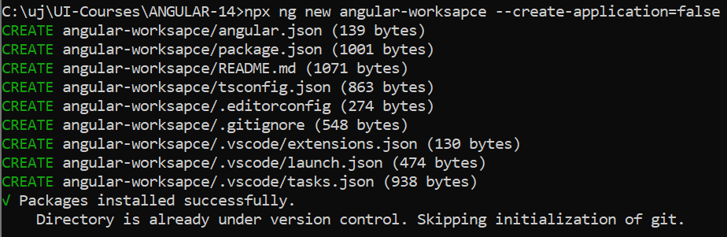

1. Angular workspace generates following file system , which you can open in VS Code.

C:\UI-Course/Angular-14\angular-workspace

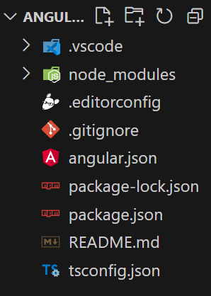

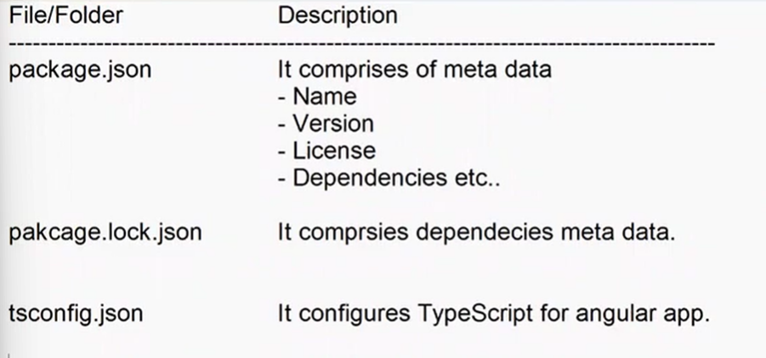

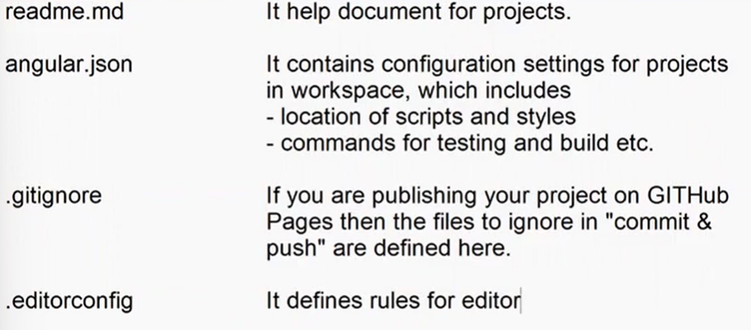

node_modules All library files are kept here

[library installed using NPM]

Vscode Angular language Service

Create a new Project

1. Open terminal for your workspace
2. Run the command

* Ng generate application shopping

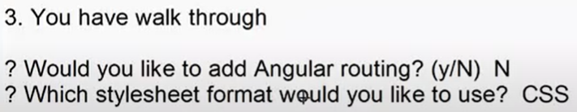

**Session-21**

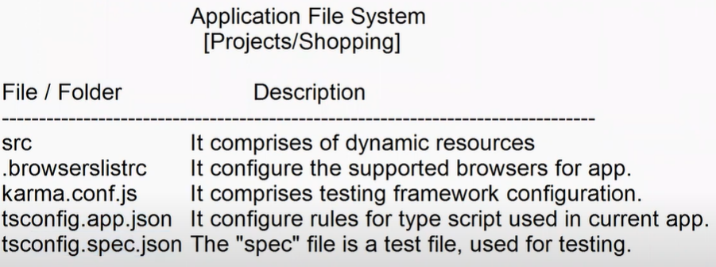

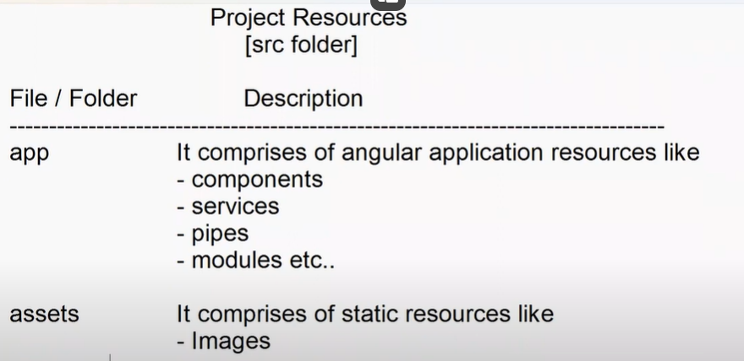

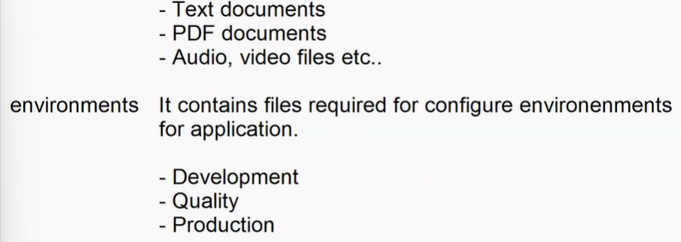

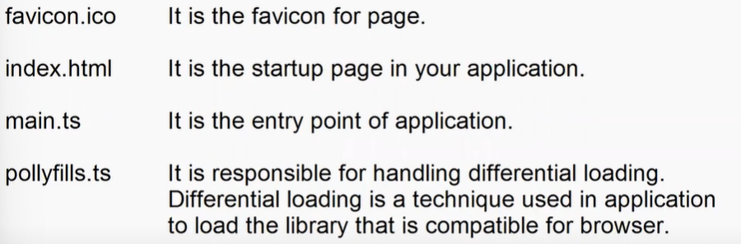

It reduces browser compatibility issues.

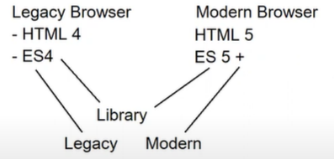

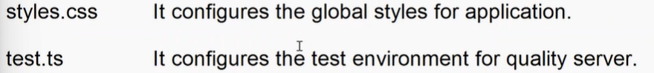

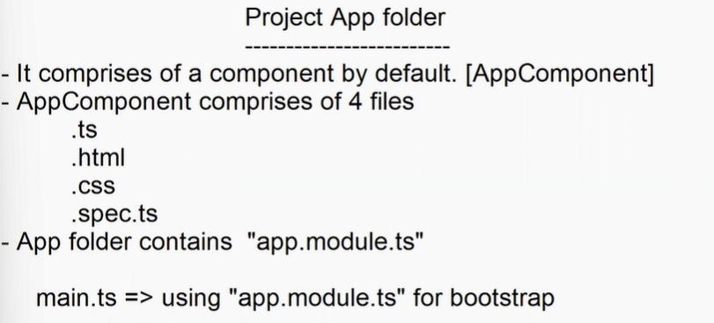

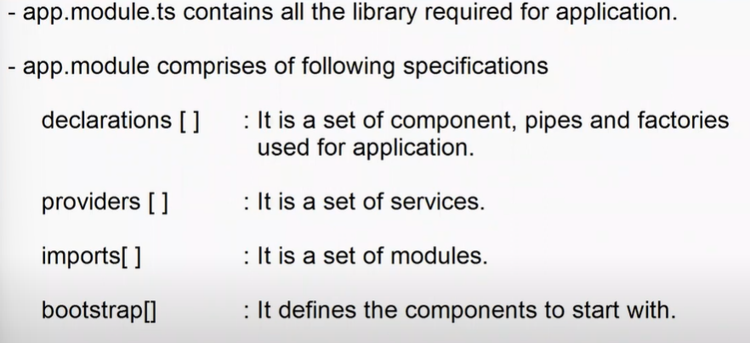

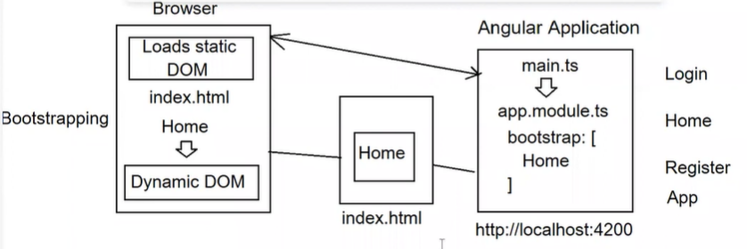

* To start your angular project
* Ng serve –project=shopping
* Angular is using “Babel” as compiler.
* Javascript based application use 2 types of compiling techniques.

1. JIT [ Just in time ]
2. AOT [ Ahead of time ]

* Javascript is light weight interpreted and JIT compiled programming language.

**Session-22**

main.ts => AppModule.ts => bootstrapComponent => App => Index.html

Angular Component ::

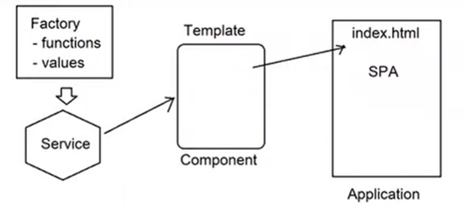

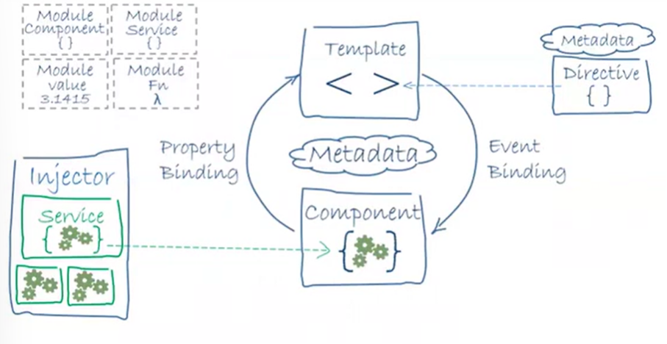

* Components are building blocks for Angular applications.
* A Component comprises of three things

1. Presentation
2. Styles
3. Functionality

* Presentation is designed in HTML
* Styles are defined using CSS, Sass , Less
* Functionality is defined using TypeScript.
* Angular allows to create custom component and also provides pre-defined componenet library called “Angular Material”.
* Component allows to create re-usable templates.
* Components are classified into 2 types based on their documentation technique.

1. Inline Component
2. Code-Behind Component

* Inline component comprises of markup , styles and functionality all defined in one file.
* Code-Behind component comprises of markup in HTML , styles in CSS and Functionaly in Typescript file.
* You can add components in 2 ways

1. Manually
2. Using CLI Commands

Inline Component Manually added to project

-----------------------------------------------------------------------------

* Component in angular is a typescript class

Class ComponentName{

}

* Component behaviour is applied to typwscript class by using the directive “@Component()”.

FAQ: What is a directive?

Ans: It is a marker or decorator used to configure any member in angular application , so that compiler can understand the type of member.

It comprises of meta data used by compiler to process the member.

Syntax:

@Componenet() Class ComponentName

{

}

* Component directive is a member of “@angular/core” library.

Import { Component } from “@angular/core”

@Component()

Export class ComponentName{

Constructor(){}

Property = value;

Method();

Get Name(){}

Set Name(){}

}

* The presentation and styles are defined by using component meta data.

@Component({

Selector:string,

Template:string,

templteUrl:string;

styles:string[],

styleUrls:string[],

animations:any[]

})

* Angular 14 introduced “Standalone components”.
* Before angular 14 services and modules are configured in “app.module.ts”.
* Angular 14 allows to configure services and modules directly in a component

@Component({

providers: [],

imports : []

})

Syntax:

HomeComponent.ts

Import { Component } from ‘@angular/core’;

@Component({

selector:’app-home’, //<app-home></app-home>

template:’<></>’,

styles:[‘selector{}’,selector{}]

})

export class HomeComponent

{

}

* Go to “app.module.ts”
* First register your component.

declarations: [HomeComponent]

providers:[]

imports : []

bootstraps:[]

* Setup in startup

Bootstrap: [HomeComponent]

* Go to index.html

<body>

<app-home></app-home>

</body>

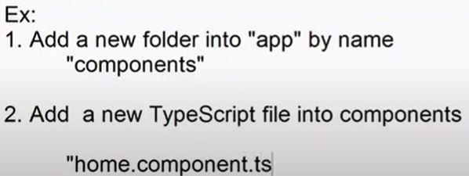

import { Component } from "@angular/core";

@Component({

    selector: 'app-home',

    template: `

    <h2>{{title}}</h2>

    <p>Welcome to Online Shopping store</p>

    `,

    styles:['h2{color:red; text-align:center}','p{color:blue}']

})

export class HomeComponent{

    title = 'Shopping Home'

}

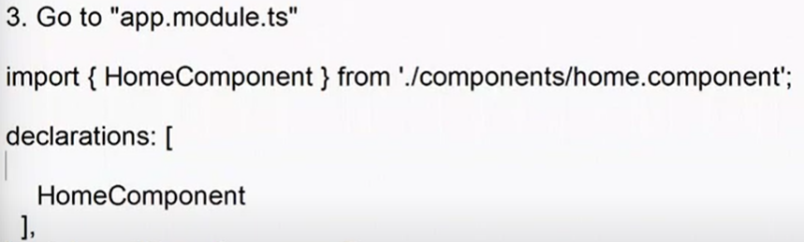

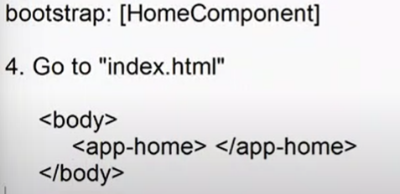

**Session-23**

* Inline techniques reduces the no of request for component.
* It improves the page load time.
* It is easy to extend.
* It is tightly coupled.
* Separation issues.
* Heavy on component

FAQ: When we have tp use inline components?

Ans : if you want a component with stable functionality , without regular extensions then better use inline technique.

**Design component using Code Behind Technique**

* In code behind techniques component is designed using individual files

.html for markup

.css for styles

.ts functionality

.spec.ts for testing

Note: Presentation comprises

1. View - complete markup document
2. Partial view - it just a portion of document

View - index.html <html></html>

Partial view - login.component.html </div>

EX:

1. Add a new folder into components
2. Add following files into login
3. login.component.ts
4. import { Component } from "@angular/core";
5. @Component({
6. selector: 'app-login',
7. templateUrl:'./login.component.html',
8. styleUrls:['./login.component.css']
9. })
10. export class LoginComponent{
11. title = "User Login";
12. }
13. login.component.html

<div class="box">

    <form action="">

        <h2>{{title}}</h2>

    <div>

        <label for="UserName">User Name</label>

        <div>

            <input type="text" name="UserName">

        </div>

    </div>

    <div>

        <label for="Password">Password</label>

        <div>

            <input type="password" Name="Password">

        </div>

    </div>

    <div>

        <button>Login</button>

    </div>

    </form>

</div>

1. login.component.css
2. .box{
3. display: flex;
4. justify-content: center;
5. align-items: center;
6. height: 500px;
7. }
8. form{
9. border: 2px solid gray;
10. border-radius: 20px;
11. padding: 20px;
12. }

**Bootstrap 5 CSS with Angular**

1. Install bootstrap into project

* npm install bootstrap –save
* npm install bootstrap-icons -save

1. import and configure bootstrap css files globally for projects

“styles.css”

@import '../../../node_modules/bootstrap/dist/css/bootstrap.css';

@import '../../../node_modules/bootstrap-icons/font/bootstrap-icons.css'

1. you can apply bootstrap icons and classes for components

bi bi-icon for icons

[www.getbootstrap.com](http://www.getbootstrap.com)

EX:

Login.component.html

<div class="box">

        <form class="border border-3 border-primary p-3 rounded rounded-3">

            <h2><span class="bi bi-person"></span>{{title}}</h2>

        <div class="mb-3">

            <label class="form-label" for="UserName">User Name</label>

            <div>

                <input type="text" name="UserName">

            </div>

        </div>

        <div class="mb-3">

            <label class="form-label" for="Password">Password</label>

            <div>

                <input type="password" Name="Password">

            </div>

        </div>

        <div class="mb-3">

            <button>Login</button>

        </div>

        </form>

</div>

**Add components using CLI commands**

1. Generate component with all files

* ng generate component name all files [4 html,css,ts,spec,ts]
* ng g c name

--dry-run -- used to test your command

C:\......\app\components> ng g c register –dry-run

1. Generate component without css

* ng g c register –inline-style=true

1. Generate component without html and without css

* ng g c register –inline-template=true –inline-css=true

1. Generate component without test file

* ng g c register –skip-tests

FAQ: How to generate inline component using cli commands?

Ans : > ng g c register –skip-tests –inlone-style=true –inline-template=true

1. Generate component without individual folder.

* ng g c register –flat –dry-run

**Session – 24**

**Multiple Components with MultiLevel hierarchy :**

1. Add a new folder into app –“Netflix”
2. Add following components

* Netflixindex
* Netflixheader
* Netflixmain
* Netflixregister

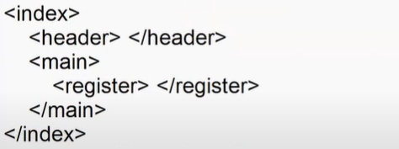

**Angular Data Binding**

* Data binding technique used by web application , where the data is access from source and binded to UI.
* Identify the changes in UI and update back to source.
* JavaScript uses lot of DOM manipulations for Data Binding.
* JavaScript uses lot of events for updating.
* Angular is a framework , it internally uses “MVC” and “MVVM” frameworks , which are popular in code separation , code reusability and data binding.
* Without DOM manipulation it can handle data binding.
* Angular is completely de-coupled from DOM.

**Simple Data Binding**

* Accessing value from any source and binding to UI.
* Angular provides various methods

1. Interpolation
2. Bind to property
3. Bind to Attribute

* Interpolation is technique of displaying data in UI using binding expression , it is not binded to any element in page.

{{}} - binding expression.

* It uses one time rendering technique.
* If you update in the source it is not effected in UI.

**Property Binding**

* Property binding allows to bind dynamic values to any element property.The properties are configure in “[]”.

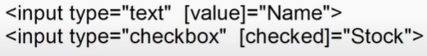

**Attribute Binding**

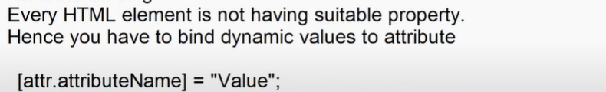

<table [attr.height]=”TableHeight”>

EX:

public stock : boolean=true;

  public tableWidth : string = '400px';

  public tableHeigth : string = '150px';

<h2>Product Detials</h2>

    <table border="1" [width]="tableWidth" [attr.height]="tableHeigth">

        <tr>

            <td>Welcome</td>

        </tr>

    </table>

    <dl>

        <dt>Name</dt>

        <dd>{{Name}}</dd>

        <dt>Stock</dt>

        <dd><input type="checkbox" [checked]="stock"> Yes </dd>

    </dl>

* Data binding is classified into 2 types.

1. One way binding
2. Two way binding.

**One Way Binding**

* Accessing data from source and bind to UI.
* Any change in UI will not update back to source.
* Interpolation, property binding , attribute binding all are one way binding technique.

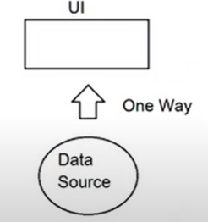

**Two Way binding**

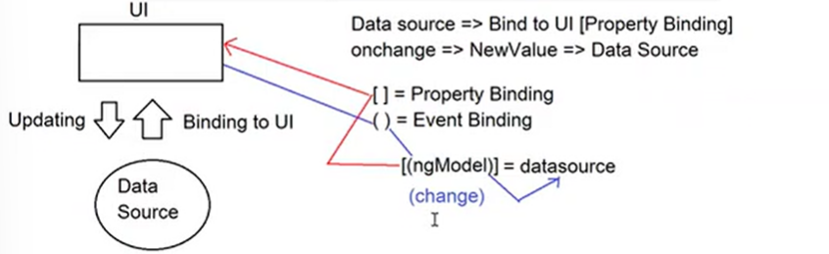

* It is the process of accessing data from source and bind to UI.
* Identify the changes in UI and update back to data source.
* To bind data with UI , we need Property binding.
* To identify changes and update back to data source , we need event binding.
* Angular uses “MVC and “”MVVM” framework implicitly to handle 2 way binding.

**MVC**

* Model View Controller
* In early 1970 by “Trygve” and formulated with language “Small Talk”.
* Code reusability and code separation.
* Every technology is using MVC.

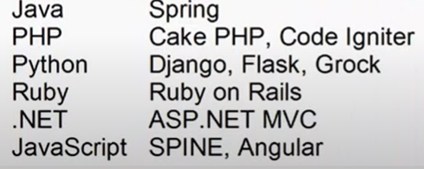

* MVC separates application into 3 components

1. Model – it represents the data we are working with , it comprises of data manipulation. In angular model is JSON.
2. View – it represents the UI. Angular view is HTML
3. Controller – it comprises of application specific logic , it handle communication between model and view. It can access data from model and bind to UI . It can identify the changes in Ui and update back to model.

* Angular uses MVC framework with the directive “ngModel”
* NgModel is referred as “Single-Source-Of-Truth”

1. Previous value
2. Current value

* NgModel uses a design pattern



* NgModel is a member of “@angular/form” library and defined in a module “FormsModule”.
* You have to import and register in “app.module.ts”.

EX:

public userName = "Pinsu";

<div class="container-fluid">

    <h2>Two Way Binding</h2>

    <dl>

        <dt>User Name</dt>

        <dd><input type="text" [(ngModel)] = "userName"></dd>

    </dl>

    <h3>Hello ! <span>{{userName}}</span></h3>

</div>

<h3>Hello ! <span [innerHTML]="userName"></span></h3>

* JavaScript promise for interacting with API is “fetch()”.
* It implicitly uses “XmlHttpRequest” object.

EX:

Databinding.html

<div class="container-fluid">

    <h2>Products Details</h2>

    <dl>

        <dt>Title</dt>

        <dd>{{products.title}}</dd>

        <dt>Preview</dt>

        <dd>

            <img [src]="products.image" width="100" height="100">

        </dd>

        <dt>Price</dt>

        <dd>{{products.price}}</dd>

        <dt>Rating</dt>

        <dd>

            <span class="bi bi-star-fill text-success"></span>

            {{products.rating.rate}} [{{products.rating.count}}]

        </dd>

    </dl>

    <div>

        <button (click)="prevClick()" class="btn btn-primary" m2-2> &laquo;</button>

        <button (click)="nextClick()" class="btn btn-primary"> &raquo;</button>

    </div>

</div>

Databinding.html

import { Component, OnInit } from '@angular/core';

@Component({

  selector: 'app-databinding',

  templateUrl: './databinding.component.html',

  styleUrls: ['./databinding.component.css']

})

export class DatabindingComponent implements OnInit {

  public products : any = {};

  public count : number =1;

  public loadProduct(url:string){

    fetch(url)

    .then(response => response.json())

    .then(data => {

      this.products = data;

    })

  }

  constructor() { }

  ngOnInit(): void {

    this.loadProduct("https://fakestoreapi.com/products/1");

  }

  public nextClick(){

    this.count++;

    this.loadProduct(`https://fakestoreapi.com/products/${this.count}`)

  }

  public prevClick(){

    this.count--;

    this.loadProduct(`https://fakestoreapi.com/products/${this.count}`)

  }

}

**Session-26**

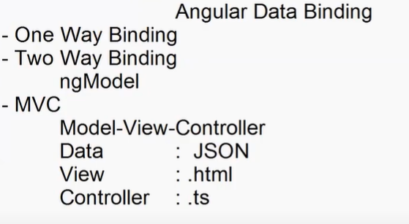

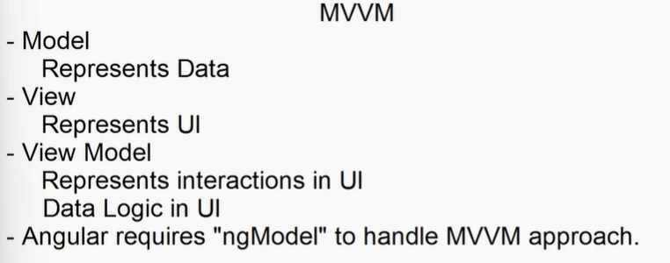

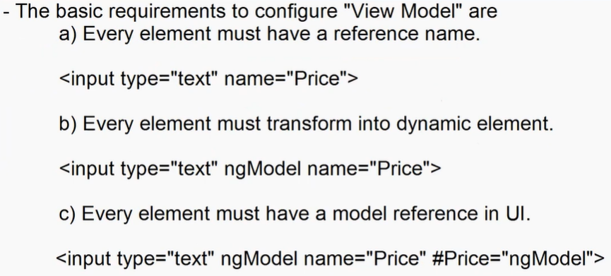

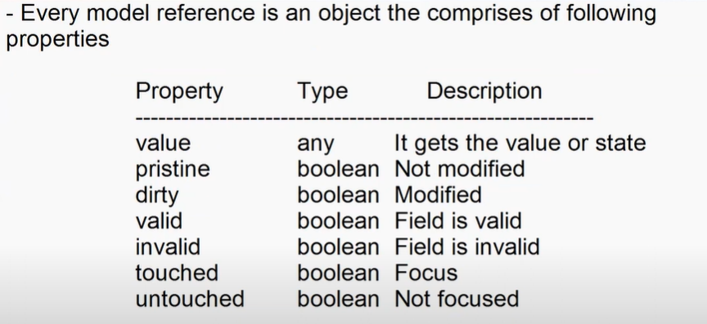

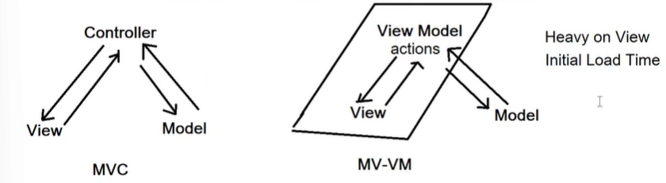**#ngModel** 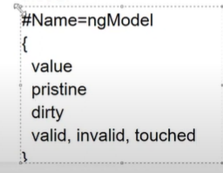

**FAQ:** What are HTML validations attributes?

Ans : minlength , maxlength , min, max , required , email , url , pattern

EX:

<div class="container-fluid">

    <div class="row">

        <div class="col-3">

            <dl>

                <dt>Name</dt>

                <dd><input type="text" required ngModel #name="ngModel" name="name"  class="form-control"></dd>

                <dt>Price</dt>

                <dd><input type="number" ngModel #price="ngModel" name="Price"  class="form-control"></dd>

                <dt>Stock</dt>

                <dd class="form-switch">

                    <input type="checkbox" #stock="ngModel" ngModel name="stock" class="form-check-input">

                </dd>

                <dt>City</dt>

                <dd>

                    <select name="city" #city="ngModel" ngModel class="form-select">

                        <option>Hyd</option>

                        <option>Delhi</option>

                    </select>

                </dd>

            </dl>

            <button [disabled]="name.invalid" class="btn btn-outline-primary w-100">Register</button>

        </div>

        <div class="col-9">

            <h2>Products Details</h2>

            <dl class="row">

                <dt>Name</dt>

                <dd>{{name.value}}</dd>

                <dt>Price</dt>

                <dd>{{price.value}}</dd>

                <dt>Stock</dt>

                <dd>{{stock.value}}</dd>

                <dt>City</dt>

                <dd>{{city.value}}</dd>

            </dl>

        </div>

    </div>

</div>

Note: you can access and manage all form element by using a “Form” reference.

Angular provides “ngForm” directive.

Syntax:

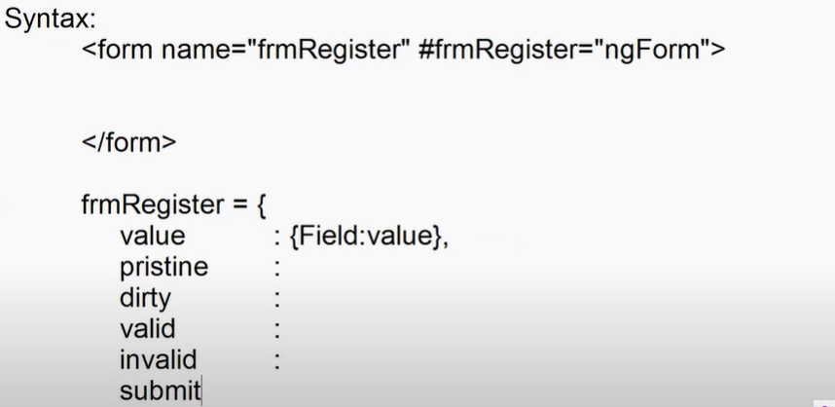

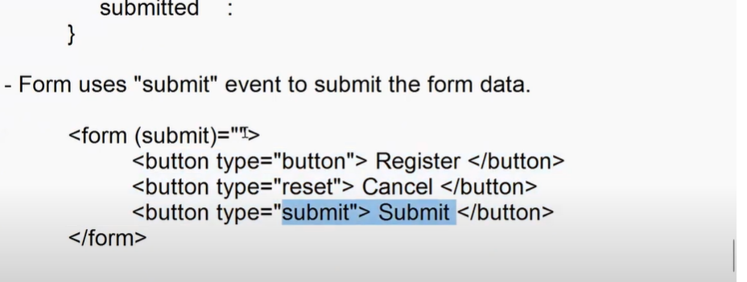

* UI is configured with

1. Form State : It configures all fields in form
2. Input State : It configures specific field in form.

* Every element in form must be dynamic “ngModel” and can be configured without any reference.

<input type =”text” name=”Price” ngModel>

**Session-27**

**Angular Directives**

* Directive is a function
* Directive can handle various functionalities

1. Can return markup
2. Can extend markup
3. Can make markup more interactive and responsive

* A directive can handle the functionalities by using various reference techniques.

1. As Element
2. As Attribute
3. As CSS Class

* A directive can return markup by using as element

<ng-template></ng-template>

<app-register></app-register>

* A directive can extend markup by using as attribute.

<input type = “text” ngModel>

* A directive can make interactive and responsive by using as class.

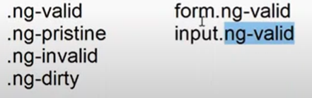

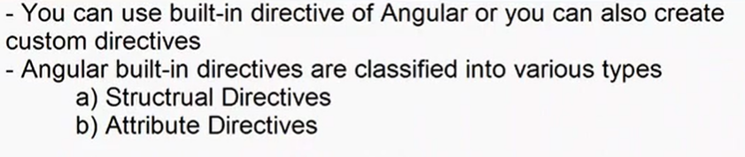

* **Structural Directives**
* Structural Directives are used to control the DOM structure.
* Adding element to DOM
* Removing element from DOM
* Update data into element in DOM.
* JavaScript handles all these operation using lot of DOM methods.

1. Create Element document.createElement()
2. Add Element into DOM appendChild() , append()
3. Remove Element DOM style attribute, delete

* Angular structural directive can manage without DOM methods.
* Angular structural directives

1. ngIf
2. ngFor
3. ngSwitch

**NgIF**

* It is a structural directive that can add or remove element from DOM.
* It is Boolean type.

<div *ngIf=”true”>

Note : Every element can have only one structural directive.

<div *ngFor=”” *ngIf=””> //invalid

FAQ: What is difference between “display: none” and “visibility:hidden” ?

Ans : “display: none” – hides element from DOM and also dispose its location.

“visibility:hidden” : hides element without disposing its locations.

* ngIf is not hiding element , it is removing element from DOM.

True = to add element

False = to remove element.

* ngIf can handle multiple blocks of DOM elements in page.

**Session-28**

**ngIf-else**

* it allows to switch between 2 blocks.

<div *ngIf=”condition; elseBlock”>

Note :

* dynamic conditions cant directly work on HTML elements , you have to use Dynamic Container [<ng-template>]

FAQ: Why you can not bind any html container to ngIf ?

Ans : ngIf is of type “TemplateRef” and only <ng-template> is assignable.

EX:

Ifdemo.component.html

<div class="container-fluid">

    <div *ngIf="false; else elseblock">If Block</div>

    <ng-template #elseblock>

        Else Block

    </ng-template>

</div>

NgIf-Then-Else ::

<div *ngIf=”condition; then trueBlock else falseBlock”>

<ng-template #trueBlock></ng-template>

<ng-template #falseBlock></ng-template>

* Then allows to render external block when condition is true.
* If “then ” is not defined it will render the current block on true.

FAQ : How to render an external block on true ?

Ans : By using “then” in “ngIf”.

EX:

<div class="container-fluid">

    <div *ngIf="true; then thenBlock else elseblock">If Block</div>

    <ng-template #thenBlock>

        Then block

    </ng-template>

    <ng-template #elseblock>

        Else Block

    </ng-template>

</div>

EX:

ifdemo.html

<div class="container-fluid">

    <h2>Product Details</h2>

    <dl>

        <dt>Title</dt>

        <dd>{{product.title}}</dd>

        <dt class="form-switch"><input type="checkbox" class="form-check-input" name="toggle" ngModel #toggle="ngModel">Toggle Preview / Details</dt>

        <dd>

            <div *ngIf="toggle.value; then previewBlock else detailsBlock"></div>

            <ng-template #previewBlock>

                <img [src]="product.image" width="200" height="200">

            </ng-template>

            <ng-template #detailsBlock>

                <dl>

                    <dt>Price</dt>

                    <dd>{{product.price}}</dd>

                    <dt>Rating</dt>

                    <dd><span class="bi bi-star-fill text-success"></span> {{product.rating.rate}}  [{{product.rating.count}}]</dd>

                </dl>

            </ng-template>

        </dd>

    </dl>

</div>

Ifdemo.ts

import { Component, OnInit } from '@angular/core';

@Component({

  selector: 'app-ifdemo',

  templateUrl: './ifdemo.component.html',

  styleUrls: ['./ifdemo.component.css']

})

export class IfdemoComponent implements OnInit {

  public product:any={};

  constructor() { }

  ngOnInit(): void {

    fetch("http://fakestoreapi.com/products/2")

    .then(response=> response.json())

    .then(data =>{

      this.product = data;

    })

  }

}

FAQ: Can we have render multiple then blocks ?

Ans: No. Angular ngIf directive can handle only one then block.

FAQ: How to render multiple then blocks ?

Ans: By using “Content Projection”

FAQ : What is content projection ?

Ans: Designing a template explicitly and rendering into view is known as “Content Projection”.

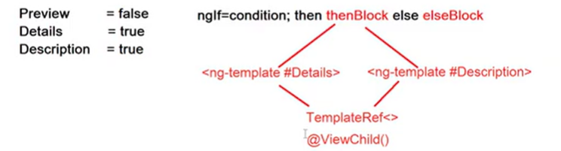

**Session-29**

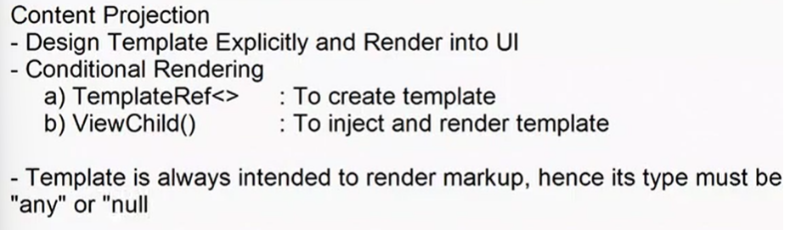

* “any” allows any type of content.
* “null” refers that content is configured dynamically.

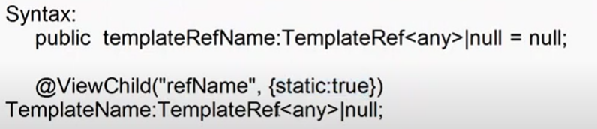

Note : Template must be static type. It renders on first request and same will be used across multiple requests in a component.

Ex:

Ifdemo.ts

import { Component, OnInit ,TemplateRef,ViewChild} from '@angular/core';

@Component({

  selector: 'app-ifdemo',

  templateUrl: './ifdemo.component.html',

  styleUrls: ['./ifdemo.component.css']

})

export class IfdemoComponent implements OnInit {

  public thenBlock:TemplateRef<any>|null = null;

  @ViewChild('thenBlock1',{static:true}) thenBlock1:TemplateRef<any>|null =null;

  @ViewChild('thenBlock2',{static:true}) thenBlock2:TemplateRef<any>|null =null;

  constructor(){}

  ngOnInit(): void {

    this.thenBlock = this.thenBlock1;

  }

  public toggleThen(){

    this.thenBlock = (this.thenBlock==this.thenBlock1)?this.thenBlock2:this.thenBlock1;

  }

}

Ifdemo.html

<div class="container-fluid">

    <button (click)="toggleThen()">Toggle</button>

    <div *ngIf="true then thenBlock else elseBlock" ></div>

    <ng-template #thenBlock1>

        Then Block-1

    </ng-template>

    <ng-template #thenBlock2>

        Then Block-2

    </ng-template>

    <ng-template #elseBlock>

        Else Block

    </ng-template>

</div>

EX

Ifdemo.html

<div class="container-fluid">

    <h2>Product Details</h2>

    <dl>

        <dt>Title</dt>

        <dd>{{product.title}}</dd>

        <dt>Price</dt>

        <dd>{{product.price}}</dd>

        <dt><button (click)="toggleClick()" class="btn w-25 btn-primary">{{buttonText}}</button></dt>

        <p><b>Toggle</b></p>

        <dd *ngIf="true; then thenBlock">

        </dd>

        <ng-template #description>

            <p class="w-25">{{product.description}}</p>

        </ng-template>

        <ng-template #preview>

            <img [src]="product.image" width="100" height="100">

        </ng-template>

    </dl>

</div>

Ifdemo.ts

import { Component, OnInit ,TemplateRef,ViewChild} from '@angular/core';

@Component({

  selector: 'app-ifdemo',

  templateUrl: './ifdemo.component.html',

  styleUrls: ['./ifdemo.component.css']

})

export class IfdemoComponent implements OnInit {

  public product:any={};

  public buttonText : string="Preview";

  public thenBlock:TemplateRef<any>|null = null;

  @ViewChild('description',{static:true}) public description:TemplateRef<any>|null=null;

  @ViewChild('preview',{static:true}) public preview:TemplateRef<any>|null=null;

  public loadProduct(){

    fetch("http://fakestoreapi.com/products/2")

    .then(response=> response.json())

    .then(data =>{

      this.product = data;

    })

  }

  constructor(){}

  ngOnInit(): void {

    this.loadProduct();

    this.thenBlock = this.preview;

  }

  public toggleClick(){

    this.buttonText = (this.buttonText=='Preview')?'Description':'Preview';

    this.thenBlock  = (this.thenBlock==this.preview)?this.description:this.preview

  }

}

FAQ: what is issues in content projection ?

Ans : Slow in rendering , it have to create a template dynamically, locate the template using in memory and inject into UI. [uses DI]

1. Provider – it locates the view in memory
2. Injector – it injects the view into component.

**Switch Selector:**

* It configures multiple template directly in UI and switch between templates without any “content projection”.
* Angular uses switch selector by using directives

1. ngSwitch
2. ngSwitchCase
3. ngSwitchDefault

* ngSwitch is defined for container that contains all templates to render . It can directly use HTML container.
* ngSwitch defines the block the render conditionally.
* It uses an expression and renders the block when expression is matching.
* ngSwiychDefault define the block to render when all the cases are not matching with given expression.

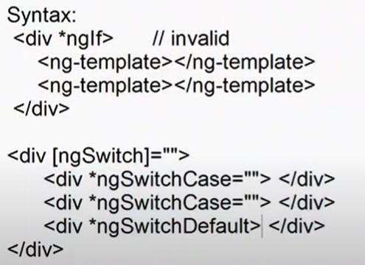

**Session-30**

**NgFor**

* it is an structural directive used as “repeater”.
* It can repeat any element.

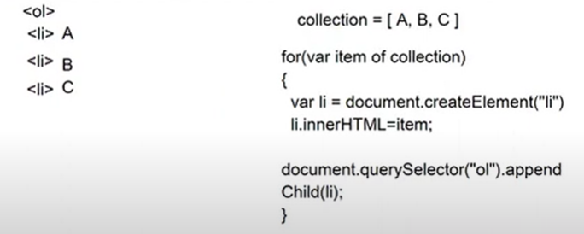

Above way is to create repeated element using java script.

* It uses an iterator for repeating elements.
* “For ” refers to an iterator pattern , it used to read elements from a collection in sequential order. [Behavioural Patterns]



* ngFor creates a new element and repeats for every item in collection and appending to parent.

javascript ::

document.createElement()

for()

appendchild()

fordemo.html

<div class="container-fluid">

    <div class="btn-group mt-2">

        <button class="btn btn-danger" *ngFor="let category of categories">{{category}}</button>

    </div>

    <div class="row">

        <div class="col">

            <h2>Categories List</h2>

            <ol>

                <li *ngFor="let category of categories">{{category}}</li>

            </ol>

        </div>

        <div class="col">

            <h2>Select Category</h2>

            <select>

                <option [value]="category" *ngFor="let category of categories">{{category.toUpperCase()}}</option>

            </select>

        </div>

        <div class="col">

            <h2>Categories</h2>

            <table class="table table-hover">

                <thead>

                    <tr>

                        <th>Category Name</th>

                    </tr>

                </thead>

                <tbody>

                    <tr *ngFor="let category of categories">

                         <td>{{category}}</td>

                    </tr>

                </tbody>

            </table>

        </div>

        <div class="col">

            <h2>Select</h2>

            <ul class="list-unstyled">

                <li *ngFor="let category of categories">

                    <input class="form-check-input" type="checkbox"> <span> {{category}}</span>

                </li>

            </ul>

        </div>

    </div>

</div>

Fordemo.ts

import { Component, OnInit } from '@angular/core';

@Component({

  selector: 'app-fordemo',

  templateUrl: './fordemo.component.html',

  styleUrls: ['./fordemo.component.css']

})

export class FordemoComponent implements OnInit {

  public categories:string[]=[];

  public loadCategories(){

    fetch("https://fakestoreapi.com/products/categories")

    .then(response => response.json())

    .then(data=>{

      this.categories=data;

    })

  }

  constructor() { }

  ngOnInit(): void {

    this.loadCategories();

  }

}

URL : <https://api.nasa.gov/mars-photos/api/v1/rovers/curiosity/photos?sol=1000&camera=fhaz&api_key=DEMO_KEY>

EX:

forDemo.ts

import { Component, OnInit } from '@angular/core';

@Component({

  selector: 'app-fordemo',

  templateUrl: './fordemo.component.html',

  styleUrls: ['./fordemo.component.css']

})

export class FordemoComponent implements OnInit {

  public mars:any={};

  public loadPhotos(){

    fetch("https://api.nasa.gov/mars-photos/api/v1/rovers/curiosity/photos?sol=1000&camera=fhaz&api_key=DEMO_KEY")

    .then(response => response.json())

    .then(data=>{

      this.mars=data;

    })

  }

  constructor() { }

  ngOnInit(): void {

    this.loadPhotos();

  }

}

Fordemo.html

<div class="container-fluid">

    <h2>Mars Rover Photos</h2>

    <table class="table table-hover">

        <thead>

            <th>Photo ID</th>

            <th>Preview</th>

            <th>Camera Name</th>

            <th>Rover viewName</th>

        </thead>

        <tbody>

            <tr *ngFor="let item of mars.photos">

                <td>{{item.id}}</td>

                <td>

                    <img [src]="item.img_src" width="200" height="200">

                </td>

                <td>{{item.camera.full_name}}</td>

                <td>{{item.rover.name}}</td>

            </tr>

        </tbody>

    </table>

</div>

Card Style ::

EX: fordemo.html

<div class="container-fluid">

    <h2>Mars Rover Photos</h2>

    <div class="d-flex flex-wrap">

        <div class="card p-2 m-2" style="width:200px" *ngFor="let item of mars.photos">

            <img [src]="item.img_src" class="card-img-top" height="150px">

            <div class="card-header">

                <h3><span class="bi-share-fill"></span> {{item.id}}</h3>

            </div>

            <div class="card-body">

                <dl>

                    <dt>Camera</dt>

                    <dd>{{item.camera.full_name}}</dd>

                    <dt>Rover</dt>

                    <dd>{{item.rover.name}}</dd>

                </dl>

            </div>

            <div class="card-footer">

                <button class="btn btn-primary w-100">

                    <span class="bi bi-eye-fill">View Details</span>

                </button>

            </div>

        </div>

    </div>

</div>

**Session-31**

* you can also use NgFor nested

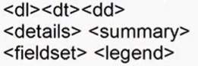

* you can use dynamic container for handling iterations without disturbing the DOM structure

<ng-container>

EX:

Fordemo.ts

import { Component, OnInit } from '@angular/core';

@Component({

  selector: 'app-fordemo',

  templateUrl: './fordemo.component.html',

  styleUrls: ['./fordemo.component.css']

})

export class FordemoComponent implements OnInit {

  public menu:any=[

    {Category: "Electronics" , Products:["Samsung TV","Mobile"]},

    {Category: "Footwear" , Products:["Nike Casuals","Lee Boot"]}

  ];

  public topics:any=[

    {Title: "HTML",Definition:"It is markup language"},

    {Title: "CSS",Definition:"It configures styles for HTML"}

  ]

  constructor() { }

  ngOnInit(): void {

  }

}

Fordemo.html

<div class="container-fluid">

    <h2>Tutorials</h2>

    <dl>

        <ng-container *ngFor="let item of topics">

            <dt>{{item.Title}}</dt>

            <dd>{{item.Definition}}</dd>

        </ng-container>

    </dl>

    <details *ngFor="let item of topics">

        <summary>{{item.Title}}</summary>

        <p>{{item.Definition}}</p>

    </details>

    <fieldset *ngFor="let item of topics">

        <legend>{{item.Title}}</legend>

        <p>{{item.Definition}}</p>

    </fieldset>

    <h2>Menu</h2>

    <ol>

        <li *ngFor="let item of menu">

            {{item.Category}}

            <ul>

                <li *ngFor="let product of item.Products">

                    {{product}}

                </li>

            </ul>

        </li>

    </ol>

    <h2>Menu</h2>

    <select>

        <optgroup *ngFor="let item of menu" [label]="item.Category">

            <option *ngFor="let product of item.Products">{{product}}</option>

        </optgroup>

    </select>

</div>

Fakestoreapi.com

GET: /products

GET: /products/1

GET: /products/categories

GET: /products/categories/electronics

EX:

Shoppingcart.html

<div class="container-fluid">

 <header class="bg-danger text-white text-center p-2 mt-2">

    <h1><span class="bi bi-cart4"></span> Shopping Online</h1>

 </header>

 <section class="mt-2 row">

    <nav class="col-2">

        <div>

            <label for="">Select a Category</label>

            <select (change)="categoryChange($event)" class="form-select">

                <option *ngFor="let item of categories" [value]="item">

                    {{item | uppercase}}

                </option>

            </select>

        </div>

    </nav>

    <main class="col-8">

        <div class="d-flex flex-wrap overflow-auto" style="height: 500px;">

            <div class="card p-2 m-2" style="width: 200px;" *ngFor="let item of products">

                <img [src]="item.image" class="card-img-top" height="150px">

                <div class="card-header" style="height:160px">

                    <p>{{item.title}}</p>

                </div>

                <div class="card-body">

                    <dl>

                        <dt>Price</dt>

                        <dd>{{item.price}}</dd>

                        <dt>Rating</dt>

                        <dd>{{item.rating.rate}} [{{item.rating.rate}}]</dd>

                    </dl>

                </div>

                <div class="card-footer">

                    <button (click)="addToCart(item.id)" class="btn btn-danger w">

                        <span class="bi bi-cart4"></span>

                        Add to Cart

                    </button>

                </div>

            </div>

        </div>

    </main>

    <aside class="col-2">

        <button class="btn btn-danger">

            <span  class="bi bi-cart"></span>

            [{{cartCount}}] Your Cart

        </button>

    </aside>

 </section>

</div>

Shoppingcart.ts

import { Component, OnInit } from '@angular/core';

@Component({

  selector: 'app-shoppingcart',

  templateUrl: './shoppingcart.component.html',

  styleUrls: ['./shoppingcart.component.css']

})

export class ShoppingcartComponent implements OnInit {

  public categories : string[]=[];

  public products:any[]=[];

  public cartItems:any[]=[];

  public cartCount:number=0;

  public getCartCount(){

    this.cartCount = this.cartItems.length;

  }

  public loadProducts(url:any){

    fetch(url)

    .then(response=>response.json())

    .then(data=>{

      this.products=data;

    })

  }

  public loadCategories(){

    fetch("https://fakestoreapi.com/products/categories")

    .then(response=>response.json())

    .then(data=>{

      data.unshift("ALL");

      this.categories=data;

    })

  }

  constructor() { }

  ngOnInit(): void {

    this.loadCategories();

    this.loadProducts("https://fakestoreapi.com/products/");

  }

  public categoryChange(e:any){

    if(e.target.value=="ALL"){

      this.loadProducts("https://fakestoreapi.com/products/");

    }

    else{

      console.log(`https://fakestoreapi.com/products/categories/${e.target.value}`);

      this.loadProducts(`https://fakestoreapi.com/products/category/${e.target.value}`);

    }

  }

  public addToCart(id:number){

    fetch(`https://fakestoreapi.com/products/${id}`)

    .then(response=>response.json())

    .then(data=>{

      this.cartItems.push(data);

      alert(data.title + "Added to Cart")

      this.getCartCount();

    })

  }

}

**Session-32**

**NgFor Properties:**

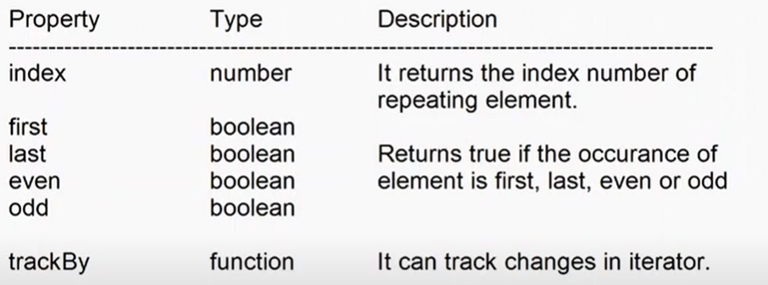

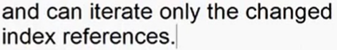

**Session-33**

Attributes Directives

* ngModel
* ngClass
* ngStyle

ngStyle :

* it defines inline styles dynamically
* it uses a style object.

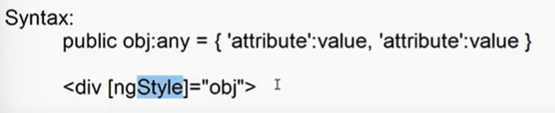

* it is often known as “stylebinding”.

Ex

Styledemo.ts

import { Component, OnInit } from '@angular/core';

@Component({

  selector: 'app-styledemo',

  templateUrl: './styledemo.component.html',

  styleUrls: ['./styledemo.component.css']

})

export class StyledemoComponent implements OnInit {

  public styleObj:any={

    'position':'',

    'left':'',

    'top':''

  }

  constructor() { }

  ngOnInit(): void {

  }

  public getPosition(e:any){

    this.styleObj={

      'position' : 'fixed',

      'left':e.clientX + 'px',

      'top':e.clientY + 'px'

    }

  }

}

Styledemo.html

<div (mousemove)="getPosition($event)">

    <div style="height:1000px">

    </div>

    <img [ngStyle]="styleObj" src="/assets/flag.webp" width="50" height="50">

</div>

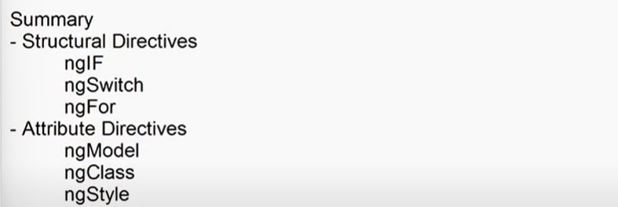

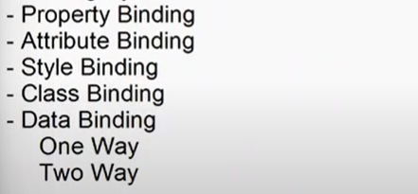

Component directives

* a component directives comprises of styles , logic and presentation.
* You can designed reusable templates by using component directives.
* You can uses pre-defined components or create custom components.

Syntax:

<app-login>

<app-header>

Event Binding

FAQ : What is an Event ?

Ans : event is a message sent by sender to its subscriber in order to notify the change.

Event following a software design pattern called “Observer”.

Observer is a behavioutal pattern . [Communications]

Event uses “delegate mechanism” [Function Poinbter]

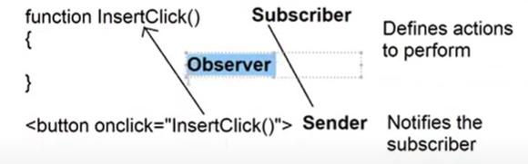

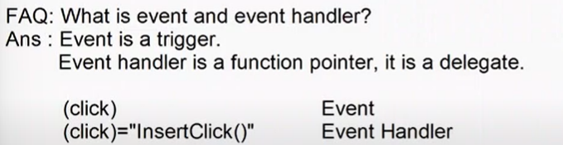

* Every event handler in angular have default parameter “$event”.
* Javascript events have 2 defult parameters “event , this”.
* $event can send information about object and event.

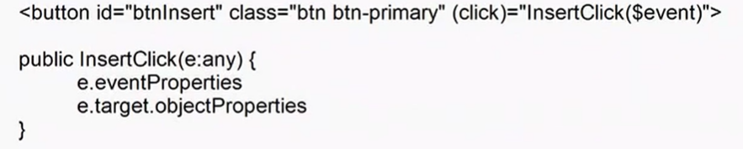

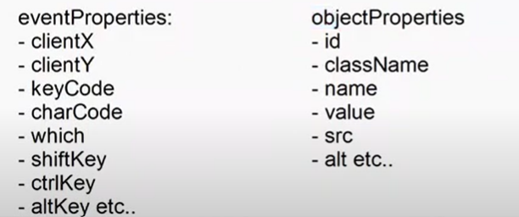

* Event allows custom arguments along with default.
* Event allow any type of arguments.



Ex:

Styledemo.ts

import { Component, OnInit } from '@angular/core';

@Component({

  selector: 'app-styledemo',

  templateUrl: './styledemo.component.html',

  styleUrls: ['./styledemo.component.css']

})

export class StyledemoComponent implements OnInit {

  constructor() { }

  ngOnInit(): void {

  }

  public insertClick(e:any,msg:string){

    document.write(`

      Button Id : ${e.target.id} <br>

      Name : ${e.target.name} <br>

      Class : ${e.target.className} <br>

      X Position : ${e.clientX} <br>

      Ctrl Key : ${e.ctrlKey} <br>

      Msg : ${msg}

    `)

  }

}

Styledemo.html

<div>

    <button id="btn" name="insert" class="btn btn-primary" (click)="insertClick($event,'Hello ! ')">Insert</button>

</div>

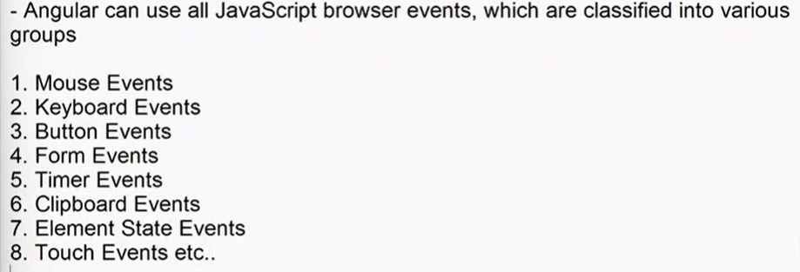

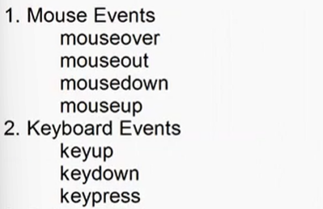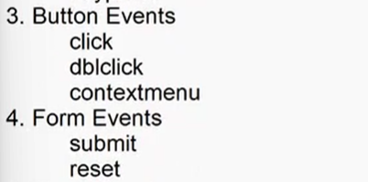

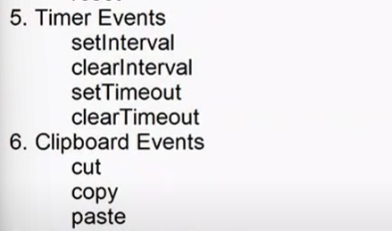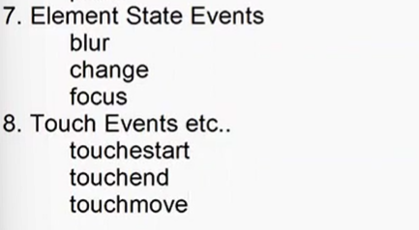

**Session-34**

**Custom Event :**

FAQ: What are custom events ?

Ans : user defined events.

FAQ: Why we need custom events?

Ans: we need custom events to configure a custom functionality for component.

Eg : [Pagination , Filter , Sorting]

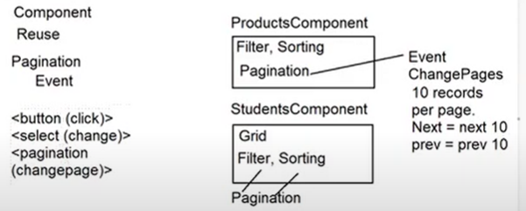

FAQ: How data is transferred/tarnsported from one component to another ?

Ans:

1. How to access a component in another component ?

<parent>

<child></child>

</parent>

1. How to transport data parent to child ?

**Session – 35**

1. You have to know how to access a component in another component ?
2. How to transfer data from parent to child ?
3. How to transfer data from child to parent ?

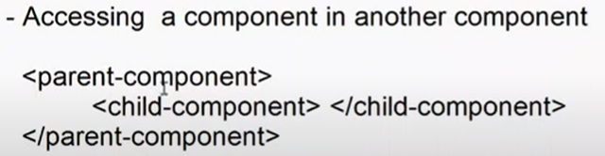

* Transporting data from parent to child
* You have to create property in child component that can accept input from parent.
* Angular can use the property for component only when it is marked as “@Input()” ,[ it is available in @angular/core library]

Syntax

@Input() public property:type

* Configure the property in component selector and accept value

<app-component [property]=”value”>

* You can send value directly or on any specific event
* You can send any type of value , primitive or non-primitive.

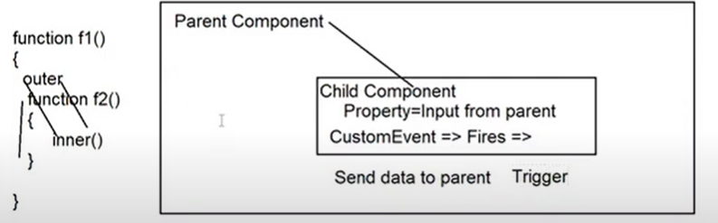

* Transporting data from child to parent
* You have to create a trigger for sending data from child to parent.
* Trigger is a custom event
* Every event in angular is derived from “EventEmitter” of “@angular/core”.

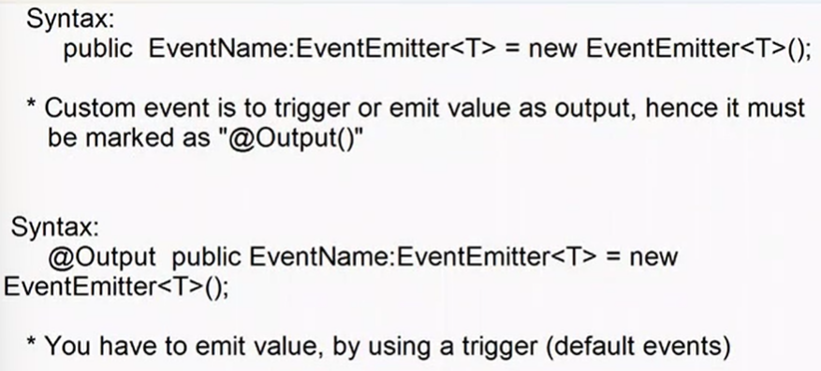

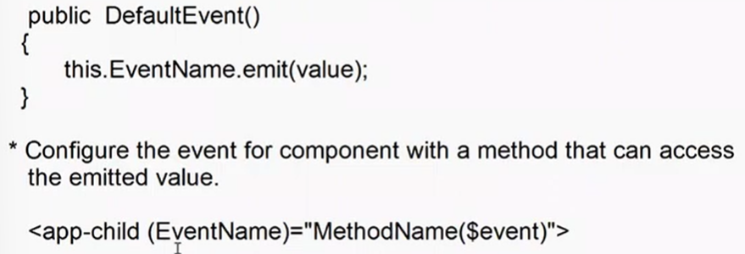

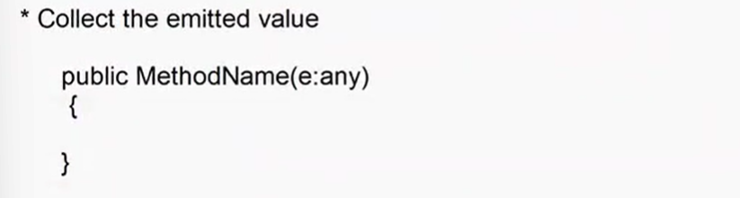

**Session-36**

* Only practicle happened on data transportation from one component to another

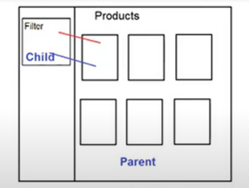

**Session-37**

High Level Angular Flow

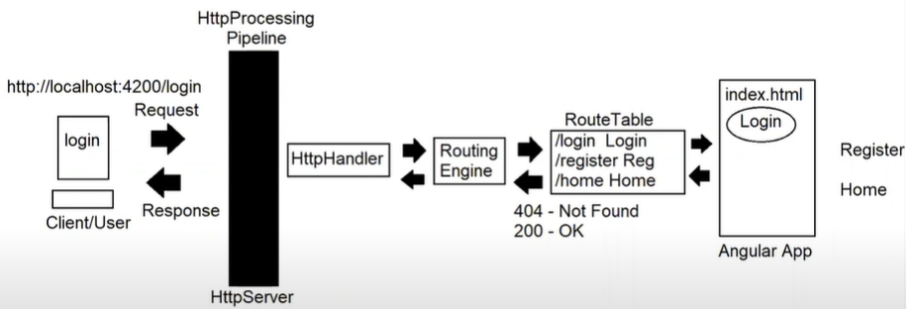

http => It is a state less protocol.

State Management

* Cookies
* Query string
* Session
* Application
* Hidden state

Component Life Cycle Hooks :

* It represents the phases of component from time it is requested to the time it is destroyed.
* A component is successfully requested when routing engine returns 200 status code [OK].
* A component is destroyed when another component is requested or application ends.
* A component have to handle various phases from Installation to destroying.
* These phases are managed by a set of methods , known as “**Life Cycle Hooks/Methods**”.
* The life cycle hooks are implicitly configured for every component and they execute implicitly.
* Client requests a component and the component is created.
* After the component is created the following phases occur.

**Phase-1** : ngOnChanges()

* the memory references for storing various values are initialized.

public price:number = 45000.44;

public price:number = undefined = 45000.44

previous value = undefined

current value = 45000.44

* the property value is binded to UI .

<input type=”text” [value]=”price”> previous value = empty string

* it identifies the changes in value by using default events



* it updates the new value into memory references.
* It is also about changes in CSSOM[CSS Object Model].

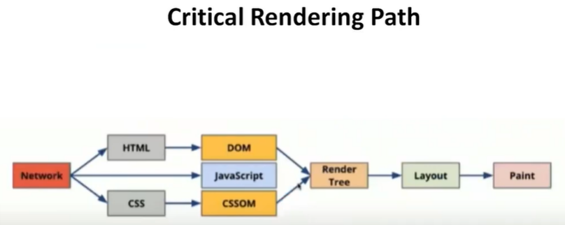

* It includes

1. Class binding
2. Style binding

Summary

* Initialization
* Property binding
* Event binding
* Class binding
* Style binding
* Data binding
* The change detection is managed by “SimpleChanges” object.

1. PreviousValue
2. CurrentValue

PreviousValue == CurrentValue //no changes

PreviousValue != CurrentValue // change detected

**Session-38**

FAQ: What is change detection ?

FAQ: Which hook method controls change detection ?

Ans: ngOnChanges();

FAQ: Which object is responsible for tracking changes ?

Ans: SimpleChanges Object

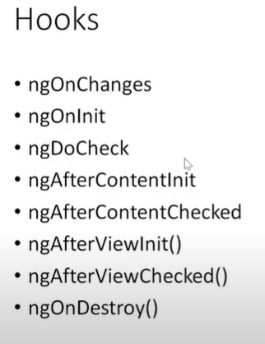

**Phase-2** : ngOnInit()

* it initializes memory required for component.
* Values are stored in the context memory.
* Values are accessible to other components that are running with in the context of current component.

FAQ: Component class have a constructor that initializes memory for component, then why you need “ngOnit()” ?

Ans: Constructor is not shared to inner components.

ngOninit shares the data to inner components by using “@Input()”.

* Memory is accessible to the child components .
* ngOnInit defines context memory .

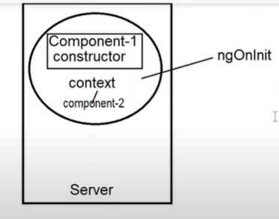

**Phase-3** : ngDoCheck()

* data in child component cant update to the parent .
* if any data is not updated implicitly.
* We have to update explicitly.
* By using @Output() and EventEmitter .
* If any change is not updated implicitly you have to update explicitly by using custom events, which are managed in “ngDoCheck()”.

FAQ: When default events will fireup ?

Ans: ngOnChanges

FAQ: When custom event will fireup ?

Ans: ngDoCheck

**Phase-4** : ngAfterContentInit()

* in this phase the output is generated and binded to UI.
* UI will render initial output.
* It implicitly renders output or implicitly renders the template [UI].
* The template are implicitly added to UI.
* It is managed by the directives

ngIF , ngSwitch , ngFor

**Phase-5** : ngAfterContentChecked()

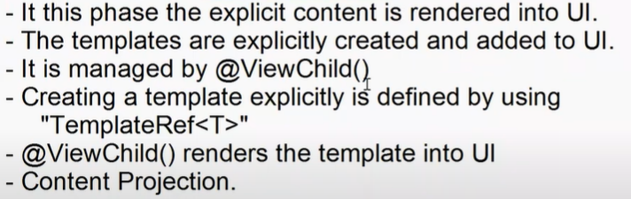

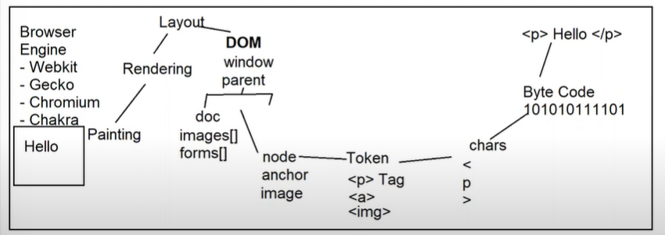

Phase – 6 : ngAfterViewInit()

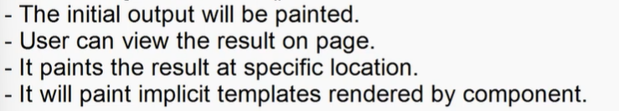

Phase – 7 : ngAfterViewChecked()

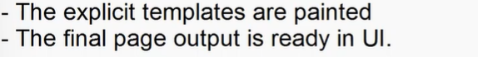

Phase-8 : ngOnDestroy()

s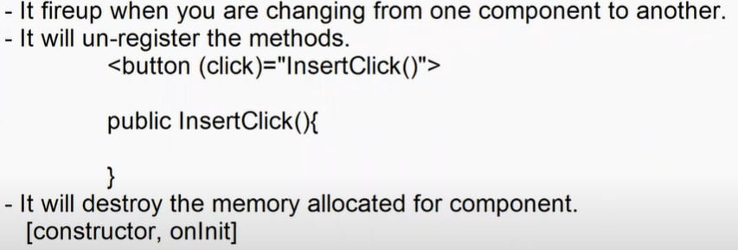

================================================================

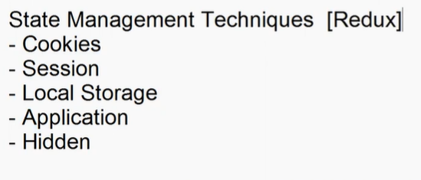

**Session-39**

EX: Change Detection :

* SimpleChanges

previousValue , currentValue

ngModel – Single-Source-Of-Truth

---------------------------------------------------------------------------------------

* Custom components
* Angular Component Library
* Angular Material
* Telerik
* DevExpress

Angular Material

* It is component library
* It provides COMPONENTS and CDK [Component Development Kit]
* Component comprises

1. HTML
2. Styles
3. Logic

* CDK defines behavior for component like “Lazy Loading”.

Setup and install angular material in project

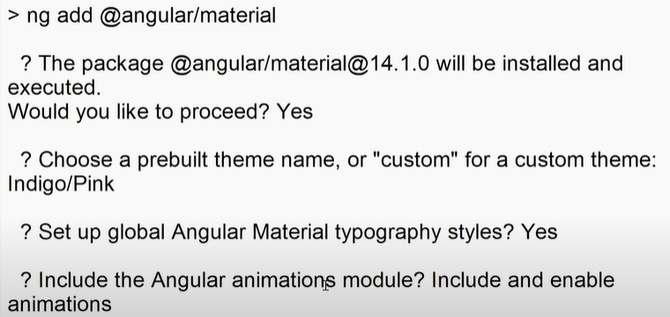

EX: Input using Angular Material

* FormField

1. Know the library required for component , you can get it

**Session-40**

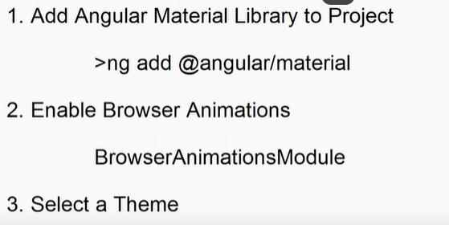

Using Components

1. mat-form-field

mat-label

mat-hint

mat-suffix

mat-prefix

1. mat-input

EX:

<h2>Bootstrap Input</h2>

    <div class="mb-2">

        <label class="form-label" for="username">User Name</label>

        <div>

            <input type="text" name="username" class="form-control">

        </div>

    </div>

    <h2>Angular Material Input</h2>

    <mat-form-field appearance="legacy">

        <mat-label>User Name</mat-label>

        <input type="text" ngModel name="username" #username="ngModel" matInput>

    </mat-form-field>

    <p>Hello ! {{username.value}}</p>

EX: Calender

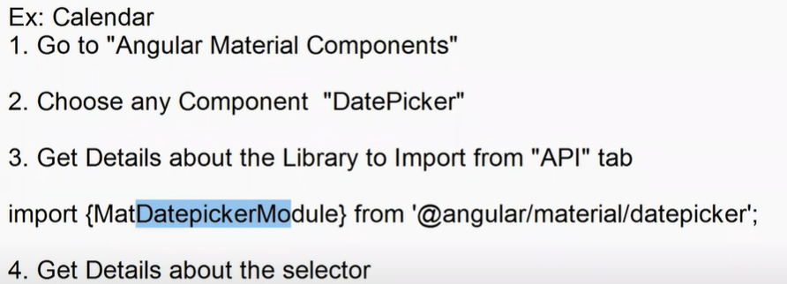

<mat-datepicker>

<mat-date-toggle>

1. Get Information about dependencies [API or Troubleshoot]

MatNativeDateModule 🡺 Dependencies for date picker

EX:

<div class="container-fluid w-50">

    <h2>Date Picker</h2>

    <mat-form-field>

        <mat-label>Deparure Date</mat-label>

        <input type="text" matInput [matDatepicker]="departure">

        <mat-datepicker-toggle matSuffix [for]="departure"></mat-datepicker-toggle>

        <mat-datepicker #departure></mat-datepicker>

    </mat-form-field>

</div>

Note : Component bindings are defined using “id” and “for”

<component #id>

<button [for]=”id”>

CDK [Component Development Kit]

EX: Lazy Loading

ngFor : Eager Loading

cdkVirtualFor : Lazy Loading

* Virtual scroll

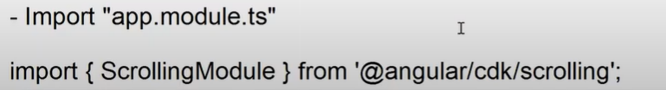

EX:

<div class="container-fluid w-50">

    <h2>Traditional Iteratior</h2>

    <div style="height:300px" class="border overflow-auto border-3 border-primary p-2">

        <ul  class="list-unstyled">

            <li *ngFor="let item of products">

                <img [src]="item.image" widht="100" height="100">

            </li>

        </ul>

    </div>

    <h2>Virtual Scroll</h2>

    <cdk-virtual-scroll-viewport itemSize="100" style="height:200px; border: 2px solid black; padding: 12px;">

        <ul class="list-unstyled">

            <li *cdkVirtualFor="let item of products">

                <img [src]="item.image" widht="100" height="100">

            </li>

        </ul>

    </cdk-virtual-scroll-viewport>

</div>

**Session-41**

Angular Services

* Technically service is a pre-defined business logic.
* You can inject and implement in your components.
* It enables reusability , maintainability , testability and extensibility.
* A set of functions and values are configured into a “factory”.
* A service is a set of factories.

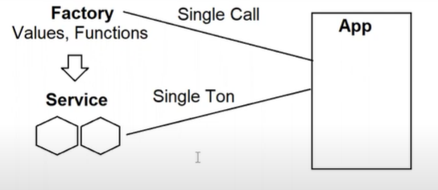

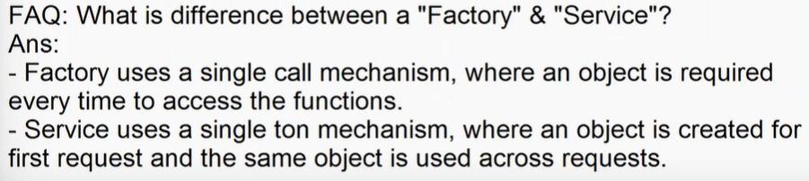

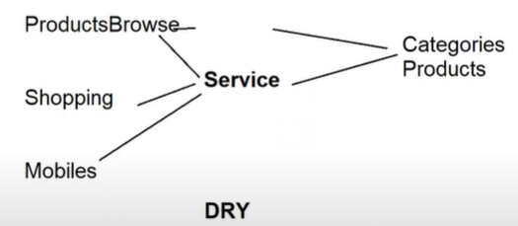

* Service uses DI [Dependency Injection] mechanism using 2 components

1. Provider
2. Injector

* Provider is a component that is used to locate the service in memory.
* You have to specify where to look for service , In angular can look for service in 3 locations

1. Root - refers to project root folder
2. Child - refers to a module in project
3. Platform - refers to workspace

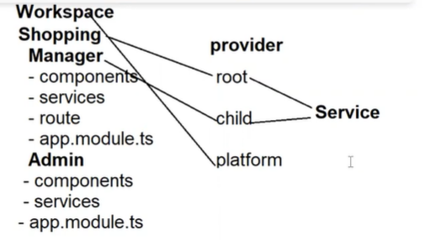

* Injector is DI component that is used to inject service into component.
* Injector uses single ton pattern and injects into any required component.
* Every service in angular must be Injectable()
* Angular service is a TypeScript class.

Configure Service ::

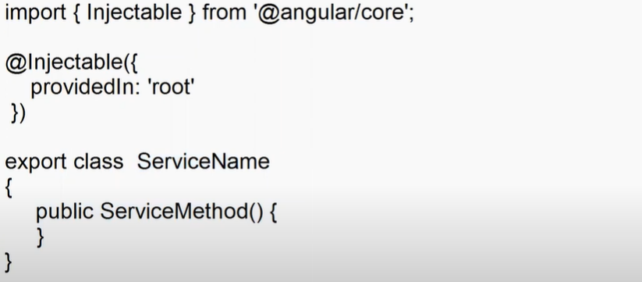

Injecting Service ::

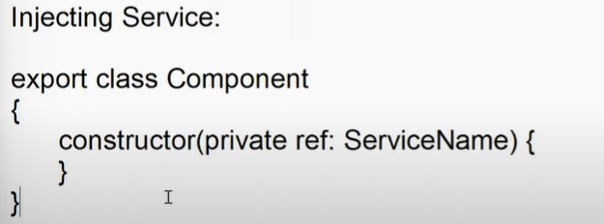

Note : you can configure the provider for service at root level using “providers[]” in app.module.ts

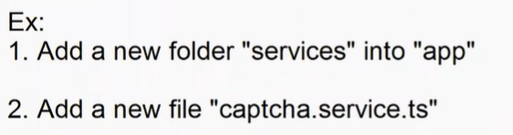

import { Injectable } from "@angular/core";

@Injectable()

export class CaptchaService{

    public generateCode(){

        let a = Math.random() * 10;

        let b = Math.random() * 10;

        let c = Math.random() * 10;

        let d = Math.random() * 10;

        let e = Math.random() * 10;

        let f = Math.random() * 10;

        let code = `${Math.round(a)} ${Math.round(b)} ${Math.round(c)} ${Math.round(d)} ${Math.round(e)} ${Math.round(f)}`;

        return code;

    }

}

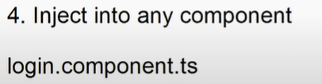

import { Component, OnInit } from "@angular/core";

import { CaptchaService } from "../../services/captcha.service";

@Component({

    selector: 'app-login',

    templateUrl:'./login.component.html',

    styleUrls:['./login.component.css']

})

export class LoginComponent implements OnInit{

    constructor(private captcha: CaptchaService){

    }

    ngOnInit(){

        this.code = this.captcha.generateCode();

    }

    title = "User Login";

    public code:string = '';

    public newCode(){

        this.code = this.captcha.generateCode();

    }

}

login.component.html

<div class="container-fluid bi-border-width">

        <form class="border border-3 border-primary p-3 rounded rounded-3">

            <h2><span class="bi bi-person"></span>{{title}}</h2>

        <div class="mb-3">

            <label class="form-label" for="UserName">User Name</label>

            <div>

                <input type="text" name="UserName">

            </div>

        </div>

        <div class="mb-3">

            <label class="form-label" for="Password">Password</label>

            <div>

                <input type="password" Name="Password">

            </div>

        </div>

        <div class="mb-3">

            <label class="form-label">Verify Code</label> <button (click)="newCode()" class="btn"><span class="bi bi-arrow-clockwise"></span></button>

            <div>

               {{code}}

            </div>

        </div>

        <div class="mb-3">

            <button>Login</button>

        </div>

        </form>

</div>

* Angular provides built-in services .

1. HttpClient Service
2. Route Service
3. Form Builder
4. Validation Services

HttpClient Service

* It is used to communicate with API.
* Already we are using “fetch()”;

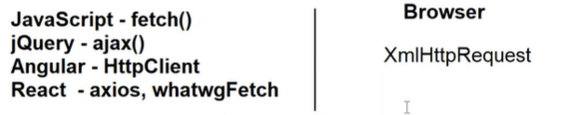

* Fetch returns data in binary
* You have to convert into JSON
* Poor in error logs
* CORS issues
* Security issues
* XSS – cross site scripting attacks
* Request forgery

**Session-42**

Angular Http Service [HttpClinet]

* Http service provides a set of properties and methods that are use to communicate with API.

JavaScript fetch()

jQuery $.ajax()

Angular HttpClient

React Axios

* HttpClient is an angular service used to communicate with API

Returns data in JSON

Handles CORS

Good Error Handling

Cross Site Scripting Attacks

Prevent Request Forgery

Can use async methods with a library “RxJS”

* HttpClient class is a member of “HttpClientModule” defined in “@angular/common/http”
* HttpClient is a service , you have to inject into component or into any another service.
* RxJS is “Reactive Extension for JavaScript”, it is async library for JavaScript app.
* RxJS provides

1. Observer
2. Subscriber

* Observer defines the actions to perform . Methods are configured as type “Observer”.

public methodName(): Observer<T>{

}

* Async methods cant execute directly
* You have to execute async methods using “Subscriber”.

methodName() //sync

methodName().subscribe() //async

**Session-43**

Angular Pipes

Summary

* Angular Components
* Angular Services
* Pipe is used to transform data.
* The data accessed from various sources is not presented in the same format.
* The data is transformed according to default formats of frontend language.

price:number = 45000.40;

{{price}} //45000.4

mfd:any = new Date(“2021-01-20”);

{{mfd}} // presents both date and time.

* You have to explicitly transform data and display in user friendly format.
* JavaScript depends on lot of methods . [String , Array ,Date]

{{mfd.toLocaleDateString()}}

{{mfd.toLocaleDateString()}}

{{mfd.getDay()}} //0

* Angular provides pipes that can transform data.
* Technically pipe is a class that implements “PipeTransform” contract and comprises of “transform()”.

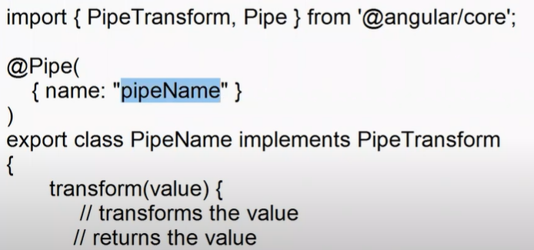

}

{{Data | pipeName}}

EX: Creating a custom Pipe

1. Add a new folder into “app” by name

“Pipes”

1. Add a new file into pipes folder

Sentence.pipe.ts

import { PipeTransform, Pipe } from "@angular/core";

@Pipe({

    name: "sentence"

})

export class SentencePipe implements PipeTransform{

    transform(value:any) {

        let firsChar = value.charAt(0);

        let restChar = value.substring(1);

        let sentence = firsChar.toUpperCase() + restChar.toLowerCase();

        return sentence;

    }

}

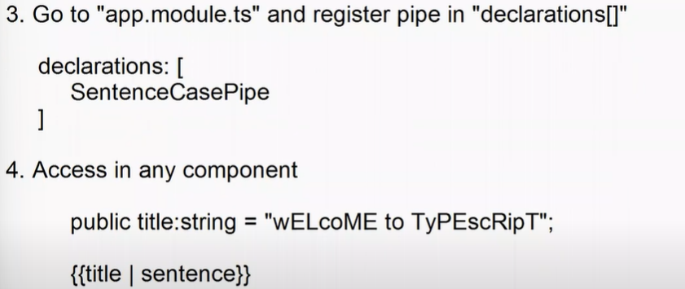

FAQ : How to define parameterized pipe ? What is parameterized pipe ?

Ans: you can configure parameters into “transform()”.

It allows to modify the pipe functionality.

The parameters are passed using “:”

{{ data | pipe:paramValue1: paramValue2}}

**Session – 44**

PipeTransform

Pipe

Custom Pipe

Parametrized Pipe

Built in Pipes

1. async
2. uppercase
3. lowercase
4. titlecase
5. number
6. currency
7. date
8. json
9. keyvalue
10. i18nSelect
11. i18nPlural
12. slice

uppercase , lowercase, titlecase : changes the captalization of text

Syntax:

{{ string | uppercase }}

number : it is used to display numeric value with decimal places and thousands separator.



{{price | number:’0.2’}}

Currency : it is similar to number , but have a currency symbol.

{{price| currency:’INR,&#8377;’}}

Date : it used to display date and time values.

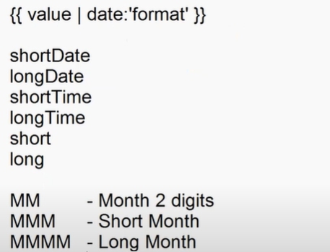

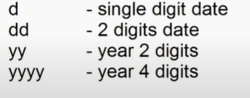

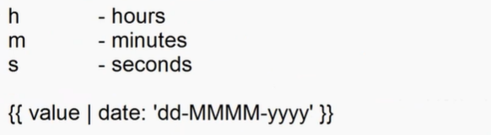

Json : it transform data into JSON fromat.

{{object | json}} // javascript JSON.stringfy()

Keyvalue: it can read keys and values from a collection.

For..of it can read all values

For..in it can read all keys

ngFor it cant use “in” , it can use only “of”.

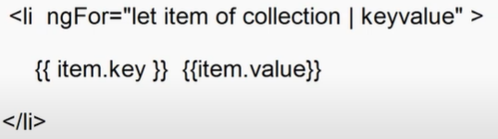

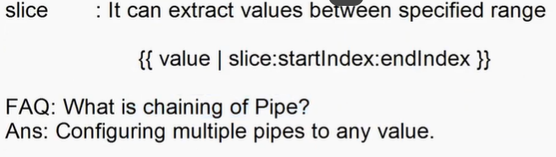

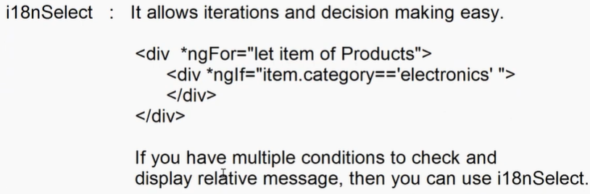



**Session - 45**

FAQ :

1. What is Pipe ?
2. How to create custom pipe ?
3. Parametrized Pipe
4. What are Built Pipes
5. What is Chaining Pipes ?

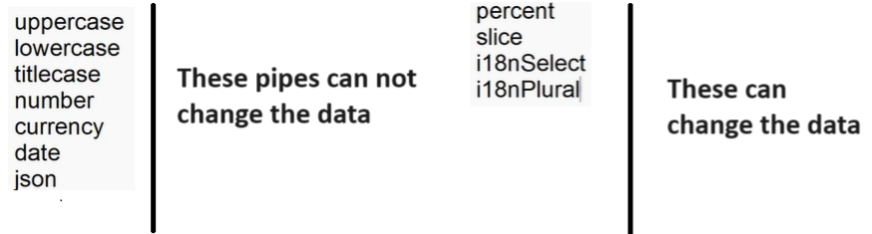

Angular Form

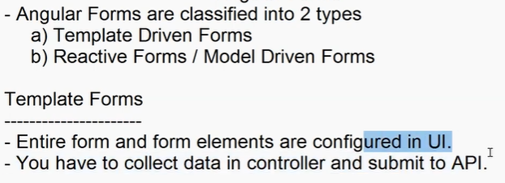

* It reduces the number of requests.
* It is heavy on UI.
* It is slow in rendering.
* It is hard to extend.
* Template driven froms are good when you need a form without regular extensions.
* To configure a <form> element Angular provides “ngForm” directive.

<form #frmRegister = “ngForm”>

Import { FormsModule } from “@angular/forms”

* NgForm provides set of properties and method to control the form and its elements

.value : it is a object that returns all fields & values.

.pristine

.invalid

.valid

.submitted

* Form element is configured by using “ngModel” directive.

<input type = “text” ngModel #username=”ngModel” name=”username”>

* NgModel provides a set of properties and methods to controls the form elements .

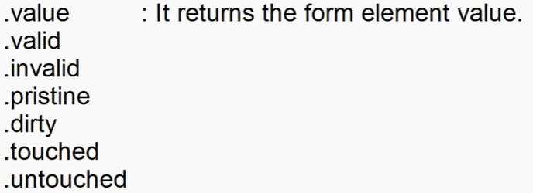

EX:

<div class="container-fluid">

    <head>Register</head>

    <form #register="ngForm">

        <dl>

            <dt>User Name</dt>

            <dd><input type="text" ngModel name="username" #username="ngModel"></dd>

            <dt>Age</dt>

            <dd><input type="number" ngModel name="age" #age="ngModel"></dd>

        </dl>

        <button>Register</button>

    </form>

    <hr>

    <h2>Details</h2>

    User Name : {{register.value.username}} (or) {{username.value}}

    <h2>Age</h2>

    Age : {{register.value.age}} (or) {{age.value}}

</div>

Template Form Validations

* Validations is the process of verifying user input.
* Validations is required to ensure that contradictonary and unauthorized data is not get stored into database.
* In web applications validations is configured

1. Server Side
2. Client Side

* Client side validations are defined in JavaScript , jQuery, Angular, React etc.
* JavaScript validates by using various methods and logic.

Verify a Number : isNaN() // in JavaScript

Verify the string length : string.length

Verify the pattern : regular expression with “match()”

Verify value provided dynamically : string “ ”.

* Angular provides validations services .
* Angular validations services can use HTML validations attributes and verify value.
* The HTML validations attributes

required

minlength

maxlength

email

url

number

pattern

* The validation services are categorized into 2 groups

1. Form state validations services
2. Input state validations services

* Form state validation services :
* These are used to verify all fields in a from simultaneously at the same time.

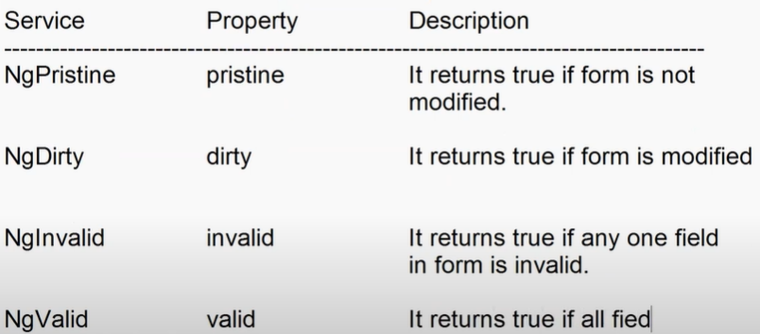





EX:



<div class="container-fluid">

    <div class="row">

        <div class="col">

            <form [ngClass]="{'invalid-style':register.invalid , 'valis-style':register.valid}" #register="ngForm">

                <h2>Register</h2>

                <dl>

                    <dt>User Name</dt>

                    <dd><input type="text" required minlength="4"  ngModel name="username" #username="ngModel"></dd>

                    <dt>Age</dt>

                    <dd><input type="number" required ngModel name="age" #age="ngModel"></dd>

                    <dt>Mobile</dt>

                    <dd><input type="text" pattern="\+91\d{10}" required ngModel name="mobile" #mobile="ngModel"></dd>

                </dl>

                <button [disabled]="register.invalid">Register</button>

                <button [disabled]="register.pristine">Save</button>

            </form>

        </div>

        <div class="col">

            <h2>Validation Services</h2>

            <dl>

                <dt>Form Not modified</dt>

                <dd>{{register.pristine}}</dd>

                <dt>Form  modified</dt>

                <dd>{{register.dirty}}</dd>

                <dt>Form is Valid</dt>

                <dd>{{register.valid}}</dd>

                <dt>Form Invalid</dt>

                <dd>{{register.invalid}}</dd>

                <dt>Form submitted</dt>

                <dd>{{register.submitted}}</dd>

            </dl>

        </div>

    </div>

</div>

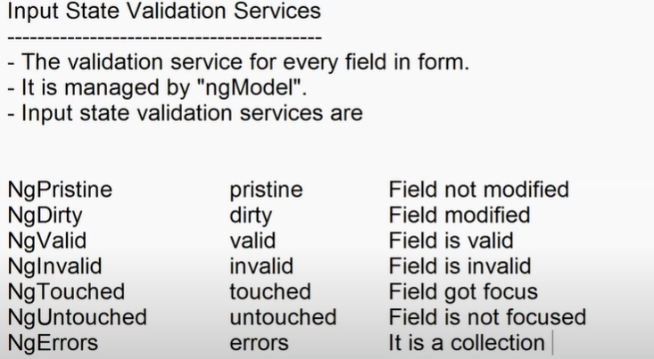



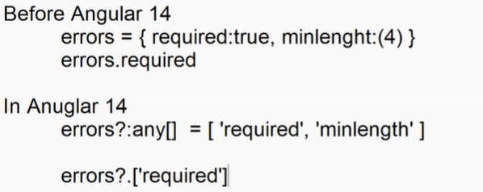

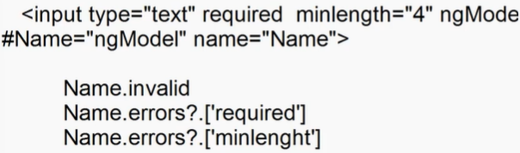

**Session - 46**

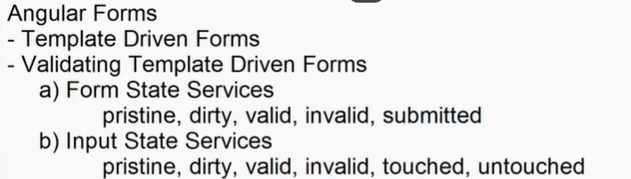

Custom Validations

import { Component, OnInit } from '@angular/core';

@Component({

  selector: 'app-templateform',

  templateUrl: './templateform.component.html',

  styleUrls: ['./templateform.component.css']

})

export class TemplateformComponent implements OnInit {

  public isCityInValid:boolean = false;

  public isEvenInvalid:boolean = false;

  constructor() { }

  ngOnInit(): void {

  }

  public verifyCity(city:string){

    if(city=="-1"){

      this.isCityInValid = true;

    }else{

      this.isCityInValid = false;

    }

  }

  public  verifyEven(n:number){

    if(n % 2 == 0 ){

      this.isEvenInvalid = false;

    }

    else{

      this.isEvenInvalid = true;

    }

  }

}

<div class="container-fluid">

    <div class="row">

        <div class="col">

            <form #register="ngForm">

                <h2>Register</h2>

                <dl>

                    <dt>User Name</dt>

                    <dd><input type="text" required minlength="4"  ngModel name="username" #username="ngModel"></dd>

                    <dd class="text-danger" *ngIf="(username.invalid && register.submitted) || (username.touched)">

                        <span *ngIf="username.errors?.['required']">User Name Required</span>

                        <span *ngIf="username.errors?.['minlength']">Name too short ..</span>

                    </dd>

                    <dt>Age</dt>

                    <dd><input type="number" required ngModel name="age" #age="ngModel"></dd>

                    <dd class="text-danger" *ngIf="(age.touched && age.invalid) || (register.submitted && age.invalid)">

                        <span>Age required</span>

                    </dd>

                    <dt>Mobile</dt>

                    <dd><input type="text" pattern="\+91\d{10}" required ngModel name="mobile" #mobile="ngModel"></dd>

                    <dd class="text-danger" *ngIf="(mobile.touched && mobile.invalid) || (mobile.invalid && register.submitted)">

                        <span *ngIf="mobile.errors?.['required']">Mobile Required</span>

                        <span *ngIf="mobile.errors?.['pattern']">Invalid mobile</span>

                    </dd>

                    <dt>Select Your City</dt>

                    <dd>

                        <select ngModel #city="ngModel" name="city" (change)="verifyCity(city.value)">

                            <option value="-1">Choose City</option>

                            <option value="delhi">Delhi</option>

                            <option value="hyd">Hyderabad</option>

                        </select>

                    </dd>

                    <dd class="text-danger" *ngIf="isCityInValid">

                        Please Select Your City

                    </dd>

                    <dt>Enter Even Number</dt>

                    <dd><input ngModel #even="ngModel" name="even" (blur)="verifyEven(even.value)" type="text"></dd>

                    <dd class="text-danger" *ngIf="isEvenInvalid">

                        Not an Even Number

                    </dd>

                </dl>

                <button >Register</button>

            </form>

        </div>

    </div>

</div>

* Angular provides pre-defined validation CSS classes .

.ng-valid

.ng-invalid

.ng-dirty

Syntax:

form.ng-invalid {}

form.ng-invalid {}

* Validation classes can verify the validation services and apply effects.

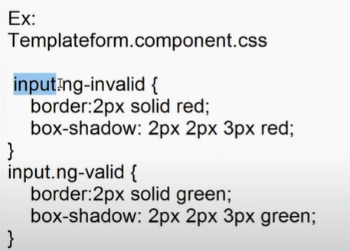

Reactive Form / Model Driven Forms

* It configures the form at controller level.
* It reduces the burden on UI.
* It makes UI light weight
* It is faster in rendering.
* It keeps the UI clean separated form logic and validations.
* It is easy to extend.
* It is easy to test.
* It is async . you can submit only specific portion of form.
* Reactive form uses a module

“ReactiveFormsModule”

* It provides various classes that are used to configure form

FormGroup <form>

FormControl <input> <select><textarea>

FormBuilder It is service

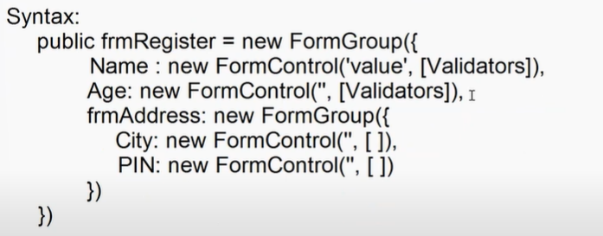

<form [formGroup] = “frmRegister”>

<input type=”text” formControlName=”Name”>

<div formGroupName = “frmRegister”>

<select formControlName=”city”></select>

</div>

</form>

[formGroup]

formControlName

formGroupName

EX:

1. Import “ReactiveFormsModule” in app.module.ts

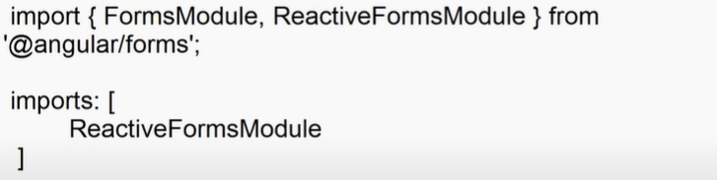

1. Add a new component

Ts file

import { Component, OnInit } from '@angular/core';

import { FormGroup, FormControl, FormBuilder, FormGroupName } from '@angular/forms';

@Component({

  selector: 'app-reactiveform',

  templateUrl: './reactiveform.component.html',

  styleUrls: ['./reactiveform.component.css']

})

export class ReactiveformComponent implements OnInit {

  constructor() { }

  ngOnInit(): void {

  }

  public register = new FormGroup({

    Name : new FormControl('John'),

    Age : new FormControl(0),

    Address : new FormGroup({

      City: new FormControl('Hyd'),

      Pin : new FormControl('')

    })

  })

  get City(){

    return this.register.controls.Address.controls.City;

  }

}

Html file

<div class="container-fluid">

    <div class="row">

        <div class="col">

            <h2>Register</h2>

    <form [formGroup]="register">

        <dl>

            <dt>Name</dt>

            <dd><input type="text" formControlName="Name"></dd>

            <dt>Age</dt>

            <dd><input type="text" formControlName="Age"></dd>

            <div formGroupName="Address">

                <h3>Contact Details</h3>

                <dl>

                    <dt>City</dt>

                    <dd>

                        <select formControlName="City">

                            <option>Delhi</option>

                            <option>Hyd</option>

                        </select>

                    </dd>

                    <dt>Postal Code</dt>

                    <dd>

                        <input type="text" formControlName="Pin">

                    </dd>

                </dl>

                <button class="btn btn-primary">Register</button>

            </div>

        </dl>

    </form>

        </div>

        <div class="col">

            <h3>Details</h3>

            <dl>

                <dt>Name</dt>

                <dd>{{register.value.Name}}</dd>

                <dt>Age</dt>

                <dd>{{register.value.Age}}</dd>

                <dt>City</dt>

                <dd>{{register.value.Address?.City}}</dd>

                <dd>{{City.value}}</dd>

                <dt>Postal Code</dt>

                <dd>{{register.value.Address?.Pin}}</dd>

            </dl>

        </div>

    </div>

</div>

* To update partial details you have to use “patchValue()”.

Note : FormGroup and ForControl are using “Single Call”.

you can use a “FormBuilder” service [single ton].

group() <form>

control() <input> <select><textarea>

array()

**Session - 47**

* FormBuilder “array()” is used to handle a collection of controls.
* You can add and remove controls dynamically.
* “array()” provides various methods [it is FormArray]

push() - Add new control

removeAt() - remove control

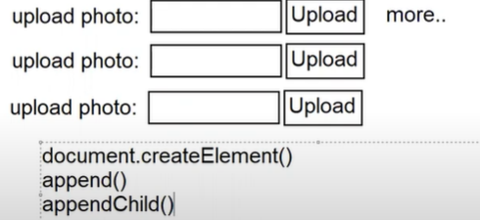

EX:

Ts file

import { Component, OnInit } from '@angular/core';

import { FormGroup, FormControl, FormBuilder, FormGroupName, FormArray } from '@angular/forms';

@Component({

  selector: 'app-reactiveform',

  templateUrl: './reactiveform.component.html',

  styleUrls: ['./reactiveform.component.css']

})

export class ReactiveformComponent implements OnInit {

  constructor(private fb : FormBuilder) { }

  ngOnInit(): void {

  }

  public register = this.fb.group({

    Name : this.fb.control(''),

    Age : this.fb.control(0),

    Address : this.fb.group({

      City : this.fb.control(''),

      Pin : this.fb.control('')

    }),

    Photos: this.fb.array([this.fb.control('')])

  })

  get City(){

    return this.register.controls.Address.controls.City;

  }

  get Photos(){

    return this.register.get('Photos') as FormArray;

  }

  public submitClicked(object:any){

    alert(JSON.stringify(object))

  }

  public updateClikced(){

    this.register.patchValue({

      Age : 26,

      Address : {

        Pin : '110006'

      }

    })

  }

  public addPhoto(){

    this.Photos.push(this.fb.control(''));

  }

  public removePhoto(i:number){

    this.Photos.removeAt(i);

  }

}

Html

<div class="container-fluid">

    <div class="row">

        <div class="col">

            <h2>Register</h2>

    <form [formGroup]="register" (submit)="submitClicked(register.value)">

        <dl>

            <dt>Name</dt>

            <dd><input type="text" formControlName="Name"></dd>

            <dt>Age</dt>

            <dd><input type="text" formControlName="Age"></dd>

            <div formGroupName="Address">

                <h3>Contact Details</h3>

                <dl>

                    <dt>City</dt>

                    <dd>

                        <select formControlName="City">

                            <option>Delhi</option>

                            <option>Hyd</option>

                        </select>

                    </dd>

                    <dt>Postal Code</dt>

                    <dd>

                        <input type="text" formControlName="Pin">

                    </dd>

                    <dt>Upload Photo <button type="button" (click)="addPhoto()" class="btn btn-link">more..</button></dt>

                    <dd *ngFor="let item of Photos.controls; let i = index">

                        <input type="file" formControlName="i"> <button class="btn btn-primary">Upload</button> <button (click)="removePhoto(i)" class="btn btn-danger m-1"><span class="bi bi-trash"></span></button>

                    </dd>

                </dl>

                <button class="btn btn-primary">Register</button>

                <button type="button" (click)="updateClikced()" class="btn btn-success m-1">Update</button>

            </div>

        </dl>

    </form>

        </div>

        <div class="col">

            <h3>Details</h3>

            <dl>

                <dt>Name</dt>

                <dd>{{register.value.Name}}</dd>

                <dt>Age</dt>

                <dd>{{register.value.Age}}</dd>

                <dt>City</dt>

                <dd>{{register.value.Address?.City}}</dd>

                <dd>{{City.value}}</dd>

                <dt>Postal Code</dt>

                <dd>{{register.value.Address?.Pin}}</dd>

            </dl>

        </div>

    </div>

</div>

Reactive Form Validations

* Reactive form provide “Validators” class
* It is a set of validations defined for control at controller level
* No need to set validation attributes for control in html

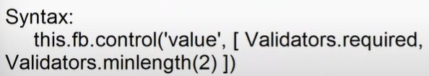

EX:

TS file

import { Component, OnInit } from '@angular/core';

import { FormBuilder, FormControl, Validators } from '@angular/forms';

@Component({

  selector: 'app-reactivevalidation',

  templateUrl: './reactivevalidation.component.html',

  styleUrls: ['./reactivevalidation.component.css']

})

export class ReactivevalidationComponent implements OnInit {

  constructor(private fb: FormBuilder) { }

  public register = this.fb.group({

    Name : this.fb.control('',[Validators.required,Validators.minLength(4)]),

    Mobile : this.fb.control('',[Validators.required,Validators.pattern(/\+91\d{10}/)])

  })

  get Name(){

    return this.register.get("Name") as FormControl;

  }

  get Mobile(){

    return this.register.get("Mobile") as FormControl;

  }

  ngOnInit(): void {

  }

}

HTML file

<div class="container-fluid">

    <form [formGroup]="register">

        <h2>Register</h2>

        <dl>

            <dt>Name</dt>

            <dd><input type="text" formControlName="Name"></dd>

            <dd class="text-danger" *ngIf="Name.touched && Name.invalid">

                <span *ngIf="Name.errors?.['required']">Name Required</span>

                <span *ngIf="Name.errors?.['minlength']">Name too short</span>

            </dd>

            <dt>Mobile</dt>

            <dd><input type="text" formControlName="Mobile"></dd>

            <dd class="text-danger" *ngIf="Mobile.touched && Mobile.invalid">

                <span *ngIf="Mobile.errors?.['required']">Mobile Required</span>

                <span *ngIf="Mobile.errors?.['pattern']">Mobile Invalid</span>

            </dd>

        </dl>

    </form>

</div>

Angular Routing

* Web application have to use various techniques.

1. Model binding
2. Caching
3. Routing
4. Event binding
5. Style binding
6. Class binding
7. State management etc ..

* Routing is a technique used in web application to configure user and SEO friendly URL’s.
* User Friendly URL’s allows user to query any content directly from URL.

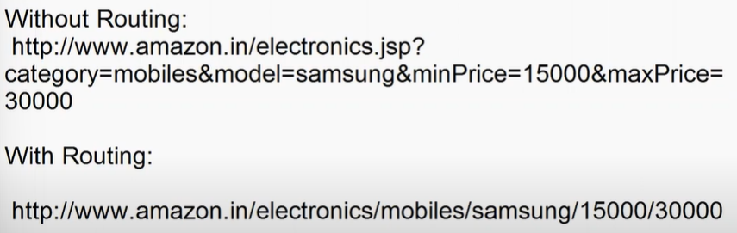

* SEO friendly URL’s allows the Crawlers to identify the exact location in page.
* Routing uses “Ajax” implicitly.
* New content are added into page without reloading the page.
* Routing is the primary feature to design SPA.
* Angular Routing library provides various services that implicitly

Handle Ajax.

Route

Router etc..

* Routing library is individually managed by community , hence routing version is different from angular version.

FAQ: What happens to Angular 3 ?

Ans: There is no Angular version 3.

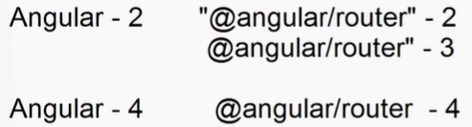

* Routing can be managed

1. Server Side [API , Dynamic , Pages]
2. Client Side [Angular , React]

**Session - 48**

Execution Flow

1. Client make a request from browser

<http://localhost:4200/login>

1. The request will handled and processed by HttpHandler
2. A routing engine is used to process the requested path by verifying in route table.
3. Route table configured in “app-routing.module.ts” file.
4. Route table is collection of routes defined by using “Routes” of “@angular/router”.

app-rotuing.module.ts

Import {Routes} from “@angular/router”;

const routes : Routes[] = [

{path:” ”,component:ComponentName}

]

@NgModule({

// import :

// export :

})

export default AppRoutingModule {}

FAQ: Why routes are configured as “const”?

Ans: Routes once initialized cant be changed . Hence they have to be configured using “const”.

Initialization of Routes is mandatory.

* Every route comprises of a link that navigates the specified path.
* Routing links are created by using “routeLink” attribute.

<a routeLink = “routePath” > Text|Image|</a>

* Every route link will load a component into memory
* You have to configure the location for rendering the component
* Render location is defined by using

<router-outlet></router-outlet>

* You can configure wild-card routes

Path: “ ” if user is not requesting any specific path

Path: “ ” if user is requesting specific path and it is not available.

EX:

1. Create a new project in workspace

* ng generate application amazon

Would you like to add Angular routing?

Yes

* <http://themes.getbootstrap.com>

**Session – 49**

* Routes

It is collection of routes

* RouterModule

It is used to import and export routes

* Router Outlet

It defines the location to render resulting markup.

* Route Parameters

Route parameter allows to query any content directly from URL.

Route parameter can be used to transport data from one component to another.

1. Configure Route parameter in route path

{path: ”details/:param1/:param2”}

FAQ: What is max limit of chars in address bar of browser ?

Ans: 2048 chars.

1. Passing value into parameter from URL

/details/val1/val2

1. Accessing the parameters by “ActivatedRoute” service

Constructor(private route: ActivatedRoute){}

this.route.snapShot.paramMap().get(key);

{param1:val1,param2:val2}

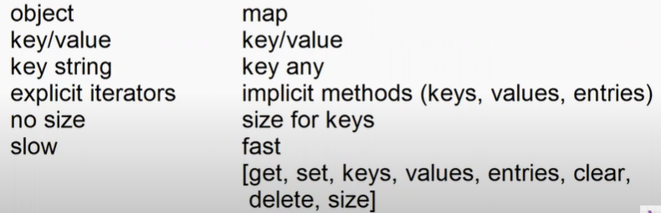

* Route Link can navigate any specific path.
* The new path you configure will be appended to existing path.

<http://localhost:4200/categories>

<a routerLink=”products/electronics”>

<http://localhost:4200/categories/products/electronics>

* You can set a new path without appending to existing path.

<a routerLink=”/products/electronics”>

<http://localhost:4200/products/electronics>

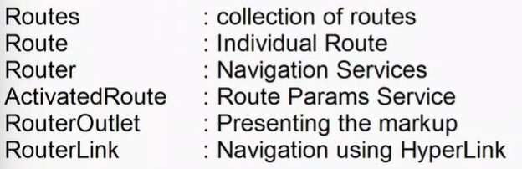

Child Routes

* You can configure a route within the existing route.
* You can access any specific path and render in existing location.
* You have to configure child route by using “children” property.

Syntax:

{path:”parent”,component:ParentComponent,

Children:[

{path:””,component: ComponentName}

]

}

* Every parent component can render child component by using

<router-outlet></router-outlet>

Summary

* Route Parameter
* Child Routes

**pending**

* Route Guards
* Route Cycle
* Lazy Routes

**Session - 50**

Route

Route Parameter – ActivatedRoute

Child Routes

-----------------------------------------------

Route Guards

Distributed Computing

* Allows 2 applications running on 2 different machines to share information
* Allows 2 application running in 2 different process on same machine to share information.

**Session - 51**

Practicle

**Session-52**

Cookies

* In Memory

Stored in browser memory

Temporary

Cookie is removed once is closed

* Persistent

Stored in your PC HDD

Permanent

You can set expiry

* You can install any 3rd party library and use for your project.
* Angular provides support for various 3rd party cookies
* npm install ngx-cookie-service –save
* it is like a map()

set() : Add a new cookie

get() : To access any cookie

delete() : to remove cookie

check() : to check existence of cookie

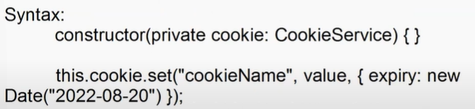

Route Guard

* it defines security for any route path.
* You can restrict access to any route path by using a Guard.
* Route Guard uses various phases .
* ng g guard name
* every route guard return a Boolean

true : allow

false : restrict

**Session – 53**

* Every component and module loads “Eager”.
* Components and module loaded into memory even when they are not in use.
* Lazy route allows to load the module or component only when requested.
* You can define lazy routes by using “loadChildren()”.

Syntax:

Eager Loading

{path: “login”, component”LoginComponent}

Lazy Loading

{path: “login” , loadChildren: () => import(“../components/logincomponent”).then(component =>

component.LoginComponent)

}

EX: Application with Module System

1. Create a new application

* ng g application hdfcbank

1. Change to “app” folder of hdfcbank in terminal

* ng g module personal –route personal –module app.module
* ng g module nri –route nri –module app.module

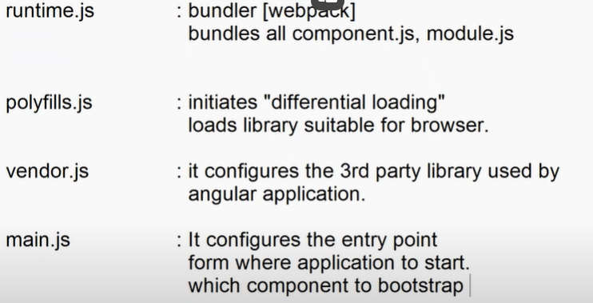

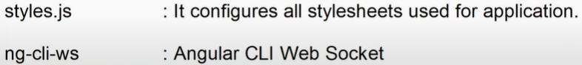

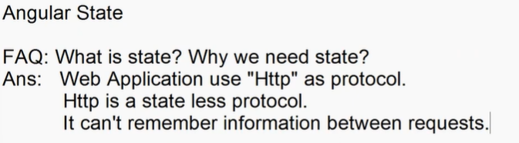

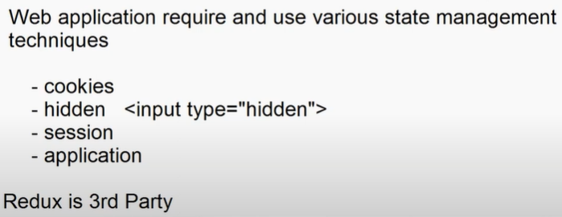

**Session - 54**

Angular Testing

* Unit testing is managed by a framework “Jasmine-Karma”.
* Testing every component method.
* Verifying and comparing the business requirements with the code developer written.

Business requirements == developer code results = pass

Business requirements != developer code results = fail

* Testing every component method comprises of 3 pahses

1. Arrange
2. Act
3. Assert

Arrange : it is the process of importing and configuring the method to test.

Act : it defines the method and values to test.[what to test]

Assert : it defines the test results . it defines the value with business requirements and reports issues.

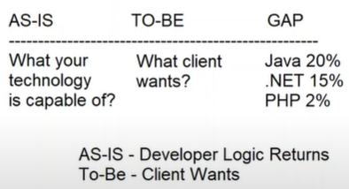

AS-IS : what developers method is returning ?

TO-BE : What client wants ?

* Jasmine-karma uses following methods

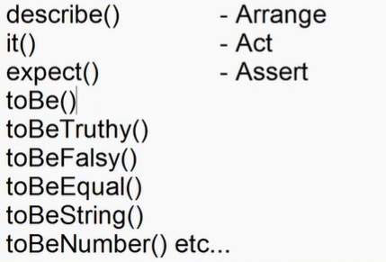

Build & Deployment

* Build is the process of checking

Syntax Errors

Dependency Errors

Injection Errorrs

Provider errors

* ng build
* build will generate “dist” folder that comprises of the repository required for Go-Live.
* Your application can GO-Live on

1. Local servers

IIS

WAMP

MAMP  
XAMPP etc..

1. Cloud Server

GIT Hub Pages

Firebase

AWS

Azure

Now

Netify etc..

Session-55

Build and Deploy

* Building is the process of Checking

Syntax Errors

Code Snippets

Dependencies

Providers

Injectors

* You can build for development or production.
* When you build for development it will just compile and identify the issues.
* When you build for production it will generate “dist” folder and bundle all resources which are ready for “Go-Live”.
* ng build [development]
* ng build –production [production]
* From angular 14 “ng-build” is default production .
* All components logic is bundled and resources are bundled and copied into “dist” folder.
* It will generate “index.html” as startup for SPA .

FAQ: Can we change default bundle folder from “dist” to any another ?

Ans: Yes.

* ng build –outputDirectory = folderName

FAQ: Can we change the startup page ?

Ans: Yes.

* ng build –baseHref = login.html
* ng build –help
* Deploying is the process of uploading and publishing all production code into server.

1. Local Server
2. Cloud Server

* To deploy to cloud server angular provides various libraries.
* You have to use the libraries to handle deployment

Note : Don’t use any manual deployment process.

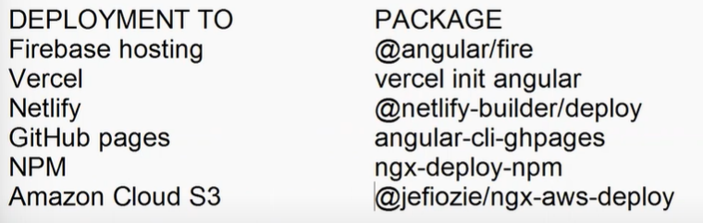

* ng add @angular/fire

Firebase Deployment

* firebase is Google cloud
* login into firebase using google account

<https://firebase.google.com/>

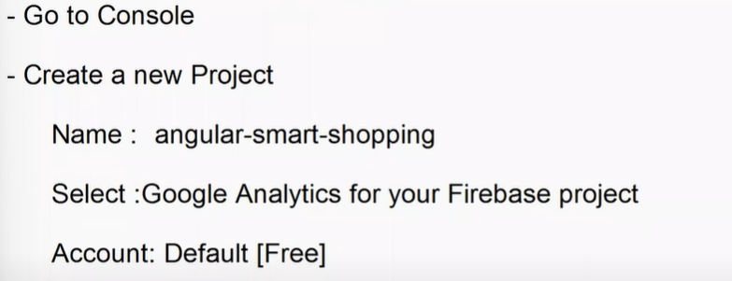

* Install firebase tools on your pc globally – [CLI] – it provides various commands that are used to publish your project into cloud .

